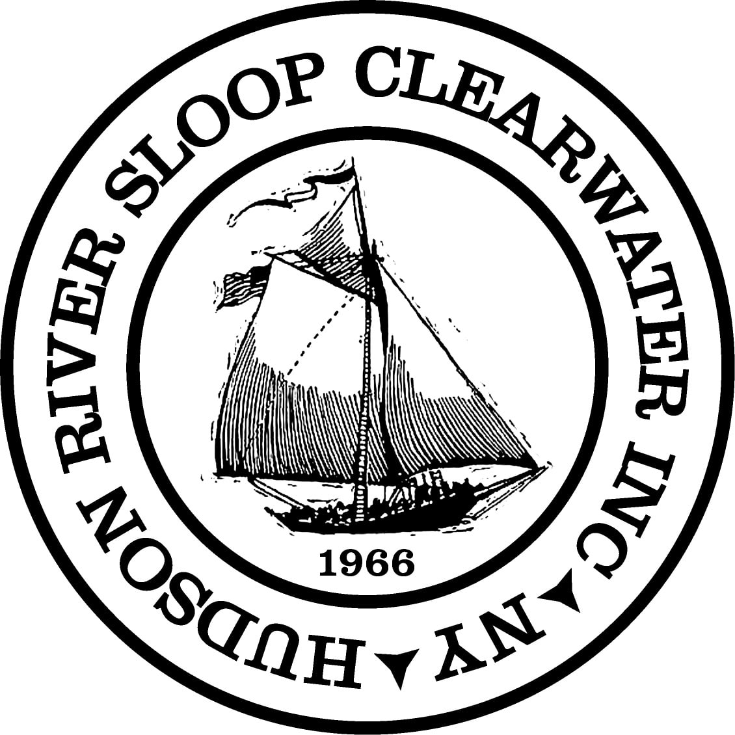

Board Manual
  - Last Edited by Greg Williams
  - January 21, 2020
Table of Contents
Introduction 2
Clearwater’s Legal and Operational Structure 3
Clearwater’s Mission 4
Clearwater’s Governance structure 5
The Role of the Board of Directors 6
The Role of Individual Directors 7
Board Member Training 8
Officers 9
Executive Director 11
Committees of the Board 12
Committees Defined by the By-Laws 13
Committees of the Board Defined by the Policies 15
Other Committees of the Board 17
Other Committees 19
Board Meetings 20
Appendix A: Certificate of Incorporation Hudson River Sloop Restoration, Inc. A-1
Appendix B: By-Laws of The Hudson River Sloop Clearwater, Inc. B-1
Appendix C: Policies of The Hudson River Sloop Clearwater, Inc. C-1
Appendix D: 2017 Board Expectations Letter D-1
Appendix E: Statement of Organizational Values E-1
Appendix F: Representing Clearwater F-1
Appendix G: Recommended Reading G-1

Introduction
This manual is intended to take The Hudson River Sloop Clearwater, Inc.’s (“The Corporations”) primary governance documents - our certificate of incorporation, our Bylaws and Policies – and make them more useful in understanding and conducting the day-to-day business of The Corporation. It seeks to do so by:
- Organizing guidance by topic, with references to all three source documents
- Providing a table of contents so readers can identify and go directly to subjects of interest
- Providing an index, so readers can more easily find all references to a particular topic or term
Because this document is organized this way, readers shouldn’t feel obliged to read it in its entirety, or in order. One should feel free to read the sections pertinent to one’s role, or the task at hand.

Intended Audience
This manual is primarily intended to satisfy the Policy requirement that board members be provided with a “Board Manual”, and thus has new board members as its primary audience. In addition, it is intended to provide a more approachable tool for members, donors and others to understand how Clearwater operates, and how our operations are shaped by different documents, created and revised throughout our history.

Clearwater’s Legal and Operational Structure
The Hudson River Sloop Clearwater, Incorporated is a 501(c)(3) not-for-profit membership corporation, incorporated in the state of New York.
The Corporation is further defined by our By-Laws, which can only be changed by a majority vote of the membership. This provides a mean by which the decisions of past and present members must be respected.
The Corporation’s actions are guided by Policies, which can be changed by a majority vote of the Board of Directors.

Clearwater’s Mission
The purpose of The Hudson River Sloop Clearwater is defined in the following way in the By-Laws:
The purpose for which this Corporation is formed, which is to be charitable and no other, is:
To defend and restore the Hudson River, one of the great and historic rivers of this nation; to investigate and conduct research into any cause or sources of contamination and destruction of this river, its tributaries and similar river systems; to inform the public of such dangers and to assist the public in taking such measures as to stop such contamination; to educate the general populace as to the importance of preserving the Hudson River, its tributaries and similar river systems; to foster the historic and cultural heritage of the Hudson River Valley from the mountains to the sea; to concern itself with the well-being of those individuals who dwell along its banks and related areas; to protect and restore other great waterways; and to conduct other actions including, but not limited to, litigation that will enhance and improve the environment of the Hudson River Valley and related areas.
The purpose is defined in far greater detail in the Policies, and summarized as follows:
The overriding goals of Hudson River Sloop Clearwater, Inc. are to defend and restore the Hudson River, its watershed and related waterways and environment (“the River and its environment”), to educate the general populace as to the importance of preserving the River and its environment and to foster the historic and cultural heritage of the Hudson River Valley. Subsidiary goals are to sustain and grow the Hudson River Sloop Clearwater as an effective, reliable and stable organization as necessary to enable Clearwater to achieve its principal goals and to inspire development of similar organizations in other regions and nations.

Clearwater’s Governance structure
The membership shall control the Corporation through the annual election of Directors. Bylaws, p.B-1
The membership of the Corporation shall consist of persons who are interested in advancing the purpose of the Corporation and who pay minimum dues, as set from time to time by the Board of Directors. Bylaws, p.B-1

The Role of the Board of Directors
The responsibilities of the board are summarized in the policies as follows:
Board Accountability
The Board accepts accountability for:
1. The connection between Clearwater and its moral owners.
2. Developing written governing policies defining the following:
a) Clearwater’s goals and objectives
b) The delegation of authority and executive limitations applicable to the Executive Director
c) The process of monitoring and evaluating Executive Director performance
d) The governance process by which the Board carries out its tasks
3. Organizational and staff performances via Executive Director limitations and evaluation.
4. The prudent fiscal management of the Corporation, including offering assistance with fundraising.
5. Periodic self-assessment.

The Role of Individual Directors
The specific duties of individual directors are loosely defined. The Policies describe a “package of information” and a “Board manual” to be distributed to Board candidates:
“To assist potential candidates in understanding the nature of the commitment they may be undertaking, the Nominating Committee shall initially distribute a package of information to all potential candidates which shall include a general description of Clearwater and active Board committees, a basic outline of Board member obligations and the Board’s current meeting calendar. At an advanced stage of the recruitment process, those candidates under serious consideration shall be presented with the Board manual and briefed on the responsibilities of Board membership.”
An example of such a “package of information” from 2017 is included as 2017 Board Expectations Letter

Board Member Training
Each board member should receive training, as described in the policies:
Policy V. Policies of the Not-For-Profit Corporation Hudson River Sloop Clearwater, Inc. Regarding the Orientation and Training of Board Members
In the interest of fostering a knowledgeable, productive and efficient Board of Directors, background materials and training shall be provided to all Board members. Responsibility for Board training shall be shared by the officers of the Corporation, the Board members who serve on the Nominating Committee and the Executive Director (“the Board training committee”). The Board training committee shall be responsible for:
1. The preparation and distribution of a Board Manual containing key written materials with which Board members should be familiar, such as historical information about Clearwater, the by-laws of the Corporation and a copy of its tax planning information, recent Board minutes and Executive Director reports, a schedule of meetings and a listing of Board and staff members.
2. Offering an orientation session to new Board members prior to their first Board meeting at which they meet key Board and staff members, tour the facilities and are orally briefed on Board procedures and current issues under consideration by the Board.
3. Establishing a mentor system whereby each new Board member is paired with an incumbent Board member in advance of their first board meeting. Mentors shall help integrate new Board members into the Board by providing guidance and encouragement.
4. Arrange for Board retreats or other training opportunities, from time to time, to improve the skills and effectiveness of the entire Board.

Officers
Officers are elected by the Board at the first meeting of the Board each year. Each is nominated by the President.

President
Section 1. The President shall preside at all meetings of the Corporation and of the Board of Directors; enforce the by-laws and carry out the policies of the Board; call such meetings as prescribed; nominate the chairpersons of all standing committees and present such nominations to the Board of Directors for confirmation; and have such other powers as ordinarily accompany the office.
ARTICLE VI DUTIES OF OFFICERS, p.B-2
The President must be a member of the Board of Directors at the time of their nomination. They are elected at the first meeting of the Board and serve a one-year term.

Vice-President
Section 2. The chief duty of the Vice President is to immediately assume the duties of President, as listed in Section 1 of Article VI, when the President is unable to serve. Under such conditions, the Vice President shall assume the title of “Acting President” until the next meeting of the Board of Directors, when a new President shall be chosen.
ARTICLE VI DUTIES OF OFFICERS, p.B-2
The President must be a member of the Board of Directors at the time of their nomination. They are elected at the first meeting of the Board and serve a one-year term.

Secretary
Section 3. The Secretary shall keep a current list of the members of the Corporation; keep an exact record of the proceedings of the Board of Directors; have charge of the records of the Corporation; maintain an index and numbered record of all policy statements adopted by the members of the Corporation and the Board of Directors; give notice to the members of the Corporation and to the Board of Directors of meetings of the Corporation and of the Board; keep in safe custody the seal of the Corporation; and when authorized by the Directors, shall affix it to any instrument requiring a seal; and, in the absence of both the President and the Vice President at any meeting, shall call to order and preside over the election of an Acting President for the meeting. The Secretary shall have the authority to delegate such responsibilities as are necessary for the efficient operation of the organization.
ARTICLE VI DUTIES OF OFFICERSSection 3 p.B-3
The Secretary need not be a member of the Board of Directors at the time of their nomination. They are elected at the first meeting of the Board and serve a one-year term. Once elected, they become a member of the Board if they are not already.

Treasurer
Section 4. The Treasurer shall, under the general supervision of the Board, have custody of the monies and investments belonging to the Corporation; shall receive and receipt for membership dues; make disbursements and investments of the Corporation’s funds; keep proper books of account; at all meetings of the Board, annually, and at other times as may be required, submit to the members and the Board of Directors a report of the receipts and disbursements, and the financial condition of the Corporation. The Treasurer shall have the authority to delegate such responsibilities as are necessary for the efficient operation of the organization.
ARTICLE VI DUTIES OF OFFICERSSection 3 p.B-3
The Treasurer need not be a member of the Board of Directors at the time of their nomination. They are elected at the first meeting of the Board and serve a one-year term. Once elected, they become a member of the Board if they are not already.

Executive Director
Section 2. The senior administrative employee, whose prime function shall be to implement the policies established by the Board of Directors and the Executive Committee, shall be known as the Executive Director. The Executive Director shall be nominated and approved by a majority vote of the Board of Directors. The Executive Director shall be paid a salary set by the Board of Directors.
ARTICLE XIV ADMINISTRATIVE DUTIES, p.B-8
I. Delegation to the Executive Director
  - It is the responsibility of the Executive Director to implement the policies and attain the organizational ends established by the Board of Directors.
  - The Executive Director is free to create, amend and modify the mechanisms by which the Board policy is implemented by whatever means he/she sees fit, provided that the means do not violate any prescriptions set forth in the Board’s policies on Executive limitations.
  - All Board authority to delegate to the staff is delegated through the Executive Director, and the Board will officially relate to the staff only through the Executive Director.
  - The Executive Director is accountable only to the Board as a whole. Permanent Board information will be presented to the Executive Director in the form of policy statements representing the intentions of the Board as a whole.
  - The Executive Director is accountable for the performance of Clearwater as a whole; for the actions of Clearwater’s employees and volunteers; and for the public perception of Clearwater.
I. Delegation to the Executive Director, p.C-7
Note: The Executive Director is not and officer of the corporation.

Committees of the Board
Board committees are to help the Board do its job, rather than to help the staff do its job. Committees will assist the Board primarily by preparing policy alternatives and implications for the Board deliberation and evaluating organizational performance.
paragraph 1 on p. C-13 of section V. Board Committees of Policy III. Policies of the Not-for-Profit Corporation Hudson River Sloop Clearwater, Inc. Regarding Board of Directors’ Job Responsibilities
Committees may be defined by the Bylaws, the Policies, or by appointment by the board.
Section 1. The Board shall elect an Executive Committee and two members of a Nominating Committee from the membership of the Board of Directors. The Board may appoint such other standing, ad hoc, and advisory committees as it may deem appropriate.
Section1 ARTICLE VII COMMITTEES OF THE BOARD pB-3
Committees of the Board may be any one of the following types:
Standing – Having an ongoing mission without a definite end. Standing committees are expected to be chaired by members of the Executive Committee.
Ad Hoc – Having a defined objective: Once the objective is achieved or abandoned, the committee is disbanded.
Advisory – Comprised of volunteers and having no voting or other power.
The President of the Board nominates chairs of all standing committees, and those nominations are approved by the Board as a whole.

Committees Defined by the By-Laws

Executive Committee (Standing)
The purpose of the Executive Committee is to make decisions on behalf of the board when required between formal meetings.
Section 3. Executive Committee: The Executive Committee of the Board shall consist of the President, Vice President, Secretary, Treasurer, and three other members to be elected by the Directors. The Executive Committee may exercise all powers of the Board of Directors between meetings of the Board, with the exception that the Executive Committee shall not hire or fire employees, unless the Board of Directors specifically delegates such power. The Executive Committee may take binding votes by telephone or e-mail where necessary and appropriate, but only if actual notice of vote is provided in advance to all Executive Committee members and only if a record of the decision is distributed by email to all Board Members promptly following the decision. Decisions of the Executive Committee may also be ratified by the Board of Directors by e-mail or telephone query to all Board Members for time-sensitive matters where necessary and appropriate, but only upon the approval of more than fifty percent of the remaining Board Members following reasonable notice, and only if a record of the decision is distributed to all Board Members by e-mail promptly following the decision. Such actions as are taken by the Executive Committee between Board meetings shall be reported to the Board of Directors at their next meeting, and shall be subject to ratification by the Board. The Executive Committee shall not have the power to take action which will overrule an established policy of the Board. The Board may delegate to, or withdraw from, the Executive Committee such powers as it may determine. If a member of the Executive Committee becomes unable to serve, replacement of such member shall be made in the same manner described in Section 1 of this Article.
ARTICLE VII COMMITTEES OF THE BOARD, p.B-3

Nominating Committee (Standing)
The Nominating Committee is responsible for:
- Determining what qualities are desired in board members with the assistance of the Executive Committee and the Executive Director
- Seeking out candidates with those qualities
- Describing the Corporation and what is expected of each Director and the Board and how Directors are elected
- Persuading candidates to run
- Providing brief summaries of each candidate’s qualifications
- Submitting those candidates to the full Board for nomination
- Guiding candidates through the election process
These duties are described in Section 1 of ARTICLE VII COMMITTEES OF THE BOARD on p.B-3, ARTICLE VIII NOMINATION OF DIRECTORS on p.B-4 and Policy IV. Policies of the Not-for-Profit Corporation Hudson River Sloop Clearwater, Inc. Regarding Recruitment and Nomination of Board of Director Candidates beginning on p.C-14.

Sloop Club Review Committee (Standing)
Section 2. Each Sloop Club may, at the discretion of the Board of Directors, have its charter renewed for a period of one year at the Corporation’s Annual Meeting. Each Club shall satisfactorily demonstrate its ability to maintain standards set by the Sloop Club Review Committee, which shall be appointed by the Board of Directors. The structure and functioning of the Club, including its relations with the Corporation, shall be governed by rules adopted from time to time by the Board of Directors.
Section 2, ARTICLE XIII SLOOP CLUBS on p.B-7 of the Bylaws

Election Judges (Ad Hoc)
The Election Judges’tabulate votes for Director Elections and other ballots and report the result to the Board. Five Election Judges are appointed by the Board, and their operation is described in Section 4 of ARTICLE XI BALLOT BY THE CORPORATION on p.B-7 of the Bylaws.

Committees of the Board Defined by the Policies
Five additional standing committees and one ad hoc committee are defined in the Policies.

Finance Committee (Standing)
The Finance Committee shall have as its objective the long-term and short-term fiscal health of the Corporation. In consultation with the Executive Director and/or the Executive Director’s designee, the committee shall develop and submit to the Board the Corporation’s proposed annual operating budget and, if necessary, revisions to that budget during the fiscal year. It shall have within its jurisdiction the responsible stewardship of the organization’s funds, including its investments. It shall concern itself with development matters and shall, in consultation with the Executive Director and/or the Executive Director’s designee, assure that appropriate steps are being taken to assure that adequate funds are being raised to provide for the Corporation’s financial needs on a long-range and short-term basis. The Treasurer of the Corporation shall be chair or cochair of the Finance Committee.
Finance Committee, p.C-26 of Committees of the Board, in Policy IX. Policies of the Not–for-Profit Corporation Hudson River Sloop Clearwater, Inc. Regarding the Organization and Functioning of its Board of Directors

Development/Resources Committee (Standing)
The Resources Committee is mentioned as a standing committee in Committees of the Board on p.C-24 of Policy IX. Policies of the Not–for-Profit Corporation Hudson River Sloop Clearwater, Inc. Regarding the Organization and Functioning of its Board of Directors, it is not further defined.

Planning/Governance (Standing)
While identified in the Policies, this committee currently has no written charge.

Program Committee (Standing)
While identified in the Policies, this committee currently has no written charge.

Properties Committee (Standing)
The Properties Committee shall have within its jurisdiction all of the physical assets of the Corporation including its real property and any vessels owned or leased by the Corporation. The objective of this committee shall be the responsible stewardship of these assets. In consultation with the Planning Committee, the Properties Committee shall from time to time make recommendations to the Board for the development, expansion or disposal of the Corporation’s physical assets so as to further the Corporation’s purposes and objectives. In consultation with the Executive Director and/or the Executive Director’s designee, the Properties Committee may procure or coordinate the provision of management and maintenance services for the properties’ stewardship.
Properties Committee, p.C-26

Board Training Committee (Ad Hoc)
In the interest of fostering a knowledgeable, productive and efficient Board of Directors, background materials and training shall be provided to all Board members. Responsibility for Board training shall be shared by the officers of the Corporation, the Board members who serve on the Nominating Committee and the Executive Director (“the Board training committee”). The Board training committee shall be responsible for:
  - The preparation and distribution of a Board Manual containing key written materials with which Board members should be familiar, such as historical information about Clearwater, the by-laws of the Corporation and a copy of its tax planning information, recent Board minutes and Executive Director reports, a schedule of meetings and a listing of Board and staff members.
  - Offering an orientation session to new Board members prior to their first Board meeting at which they meet key Board and staff members, tour the facilities and are orally briefed on Board procedures and current issues under consideration by the Board.
  - Establishing a mentor system whereby each new Board member is paired with an incumbent Board member in advance of their first board meeting. Mentors shall help integrate new Board members into the Board by providing guidance and encouragement.
  - Arrange for Board retreats or other training opportunities, from time to time, to improve the skills and effectiveness of the entire Board.
Policy V. Policies of the Not-For-Profit Corporation Hudson River Sloop Clearwater, Inc. Regarding the Orientation and Training of Board Membersp.C-18

Other Committees of the Board
Although the Board retains the authority under the by-laws to appoint such other standing or ad hoc committees as it may deem appropriate, the Board’s policy is normally to maintain the number of standing committees to its minimum level so as to simplify the operation of the organization, limit the commitment of each Board member to meeting attendance, provide for a small and clearly defined number of lines of communication at the Board level, and permit each committee’s functions and governances.
Committees of the Board on p.C-24 of Policy IX. Policies of the Not–for-Profit Corporation Hudson River Sloop Clearwater, Inc. Regarding the Organization and Functioning of its Board of Directors

Ambassadors (Standing)
This committee currently has no written charge.

Chefs for Clearwater
This committee currently has no written charge.

College Outreach (Standing)
This committee currently has no written charge.

Communications (Standing)
This committee currently has no written charge.

Diversity & Outreach (Standing)
This committee currently has no written charge.

Education (Standing)
This committee currently has no written charge.

Environmental Action (Standing)
This committee currently has no written charge.

Events (Standing)
This committee currently has no written charge.

Personnel (Standing)
This committee currently has no written charge.

Sloop (Standing)
This committee currently has no written charge.

Revival exploratory (Ad Hoc)
This committee currently has no written charge.

Other Committees

Gala Committee
The Gala committee is a committee of the staff charged with planning and executing the Corporation’s annual gala for the purpose of raising funds and celebrating achievements.

Board Meetings
Board meetings are described in ARTICLE X CORPORATION AND BOARD MEETINGS on p.B-5. They are further described in the Policies of The Hudson River Sloop Clearwater, Inc..
There shall ordinarily be four meetings of the full Board of Directors each year in addition to the Annual Meeting of the Corporation, subject to Article X, Section 2 of the by-laws (which permit additional meetings to be convened at the call of the President or seven members of the board).
The first of these meetings shall take place immediately following the Annual Meeting of the Corporation and the chief purpose of this meeting shall be the election of officers as specified in Article V, Sections 2 and 3 of the by-laws.
The second Board meeting shall take place in November and among its agenda items shall be consideration and passage of the Corporation’s operating budget for the fiscal year commencing on December 1st.
The third Board meeting shall be convened in March because this is the approximate halfway point in the year beginning with the Annual Meeting of the Corporation and Board election and shall include in the agenda an evaluation of organizational operations.
The fourth meeting of the year shall be convened in June and shall include in the agenda preparations for the Annual Meeting of the Corporation and, specifically, nominations for election to the Board of Directors.
Nothing in the foregoing should be construed as limiting matters that may be placed on the agenda of a Board meeting for discussion. With the exception of the Board meeting convened immediately after the Annual Meeting of the Corporation, it is expected that the Board meetings as described above will generally be day-long gatherings with a schedule providing for extensive discussion, fellowship and activities designed to provide education and inspiration to Board members.
Meetings of the Board on p.C-23
It should be noted that in 2018 and 2019, the Board has met nearly every month, and Board meetings have taken place in the evening, with a pot luck dinner starting at 6pm, the meeting called to order at 6:30pm, and adjourned at 8:30pm.

Meeting Minutes
The Secretary shall keep minutes of the Board’s meetings as required by Article VI,
Section 3 of the by-laws and shall make them properly available to the members of the Corporation. It is understood that such minutes are unofficial until their formal adoption by the Board, as corrected if necessary, at its subsequent meeting.
p.C-24 of Meetings of the Board, Policy IX. Policies of the Not–for-Profit Corporation Hudson River Sloop Clearwater, Inc. Regarding the Organization and Functioning of its Board of Directors
Minutes of Executive Committee meetings are distributed only to Directors, and not members except by affirmative vote of the full board.

Certificate of Incorporation Hudson River Sloop Restoration, Inc.
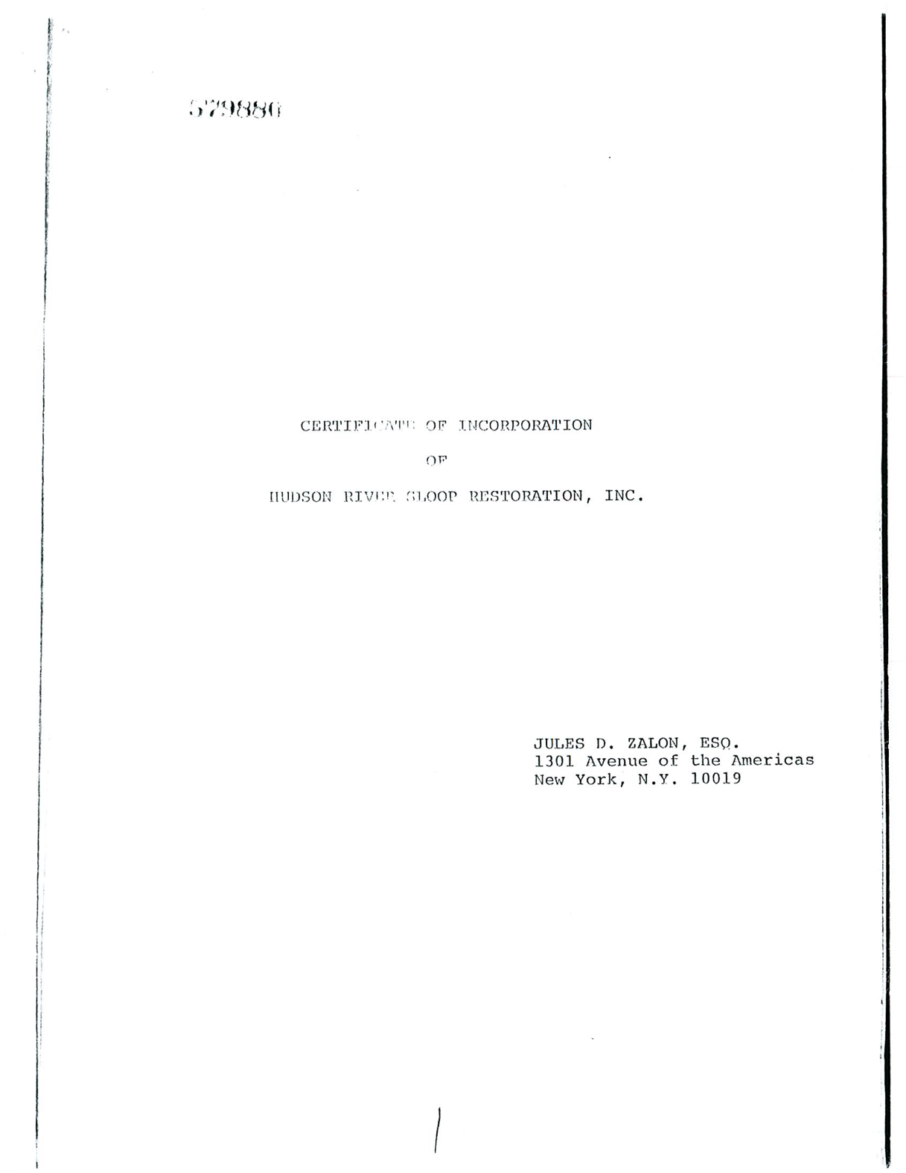
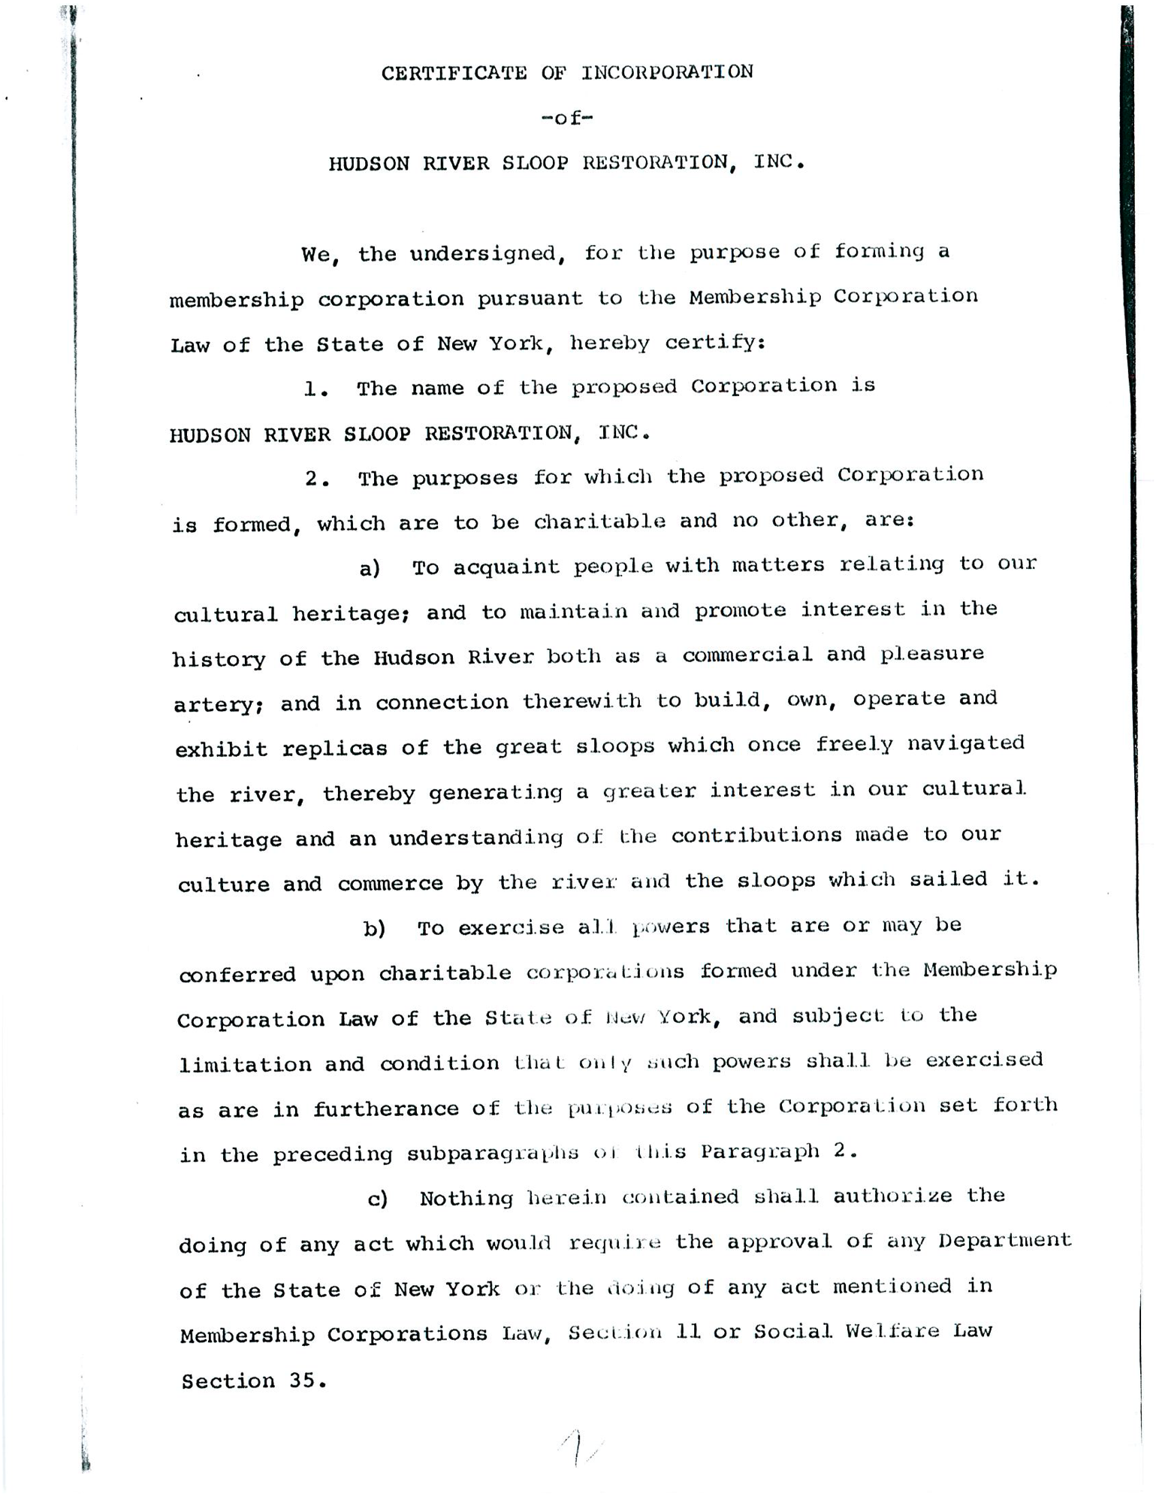
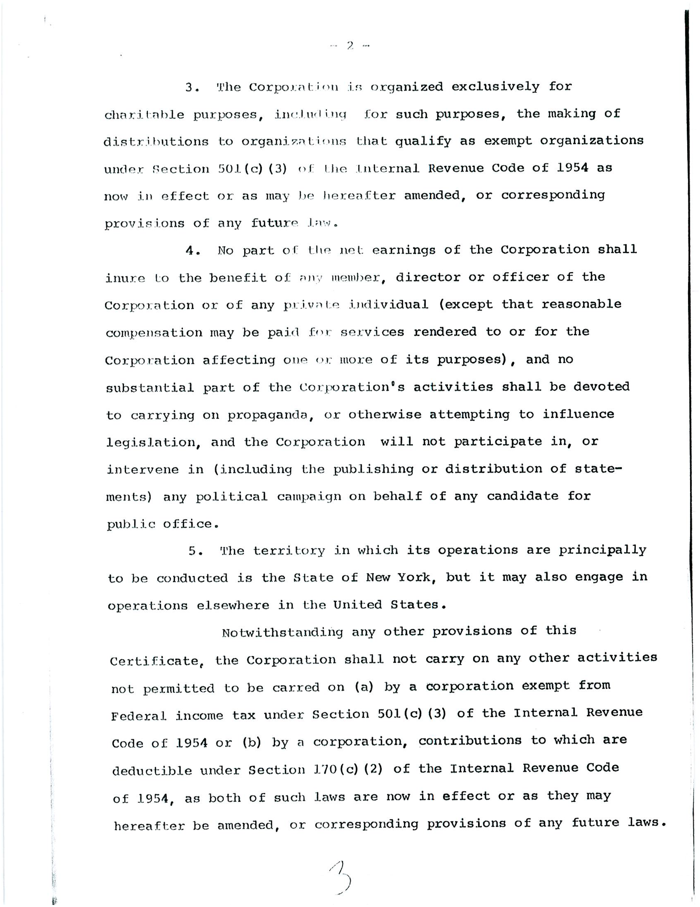
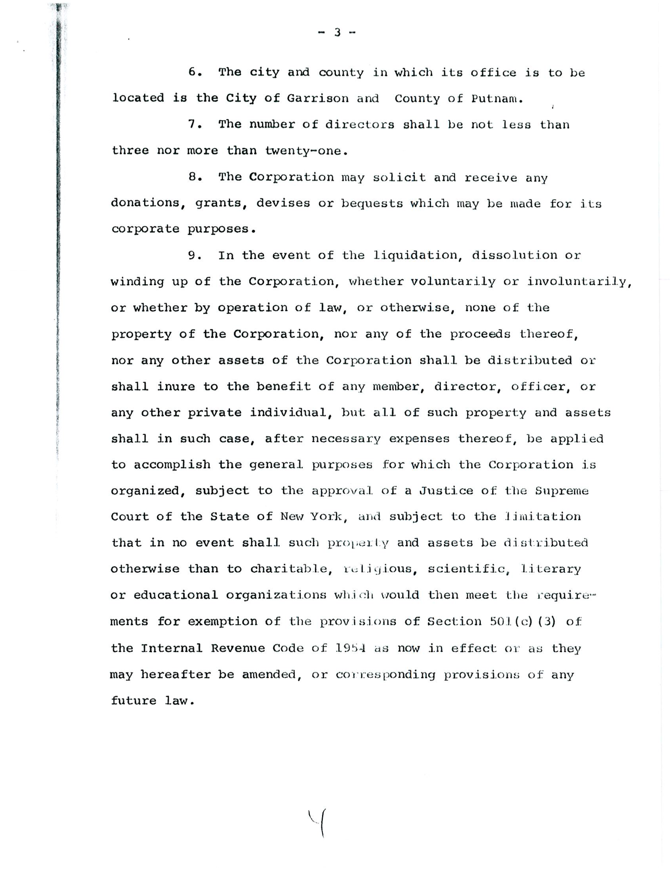
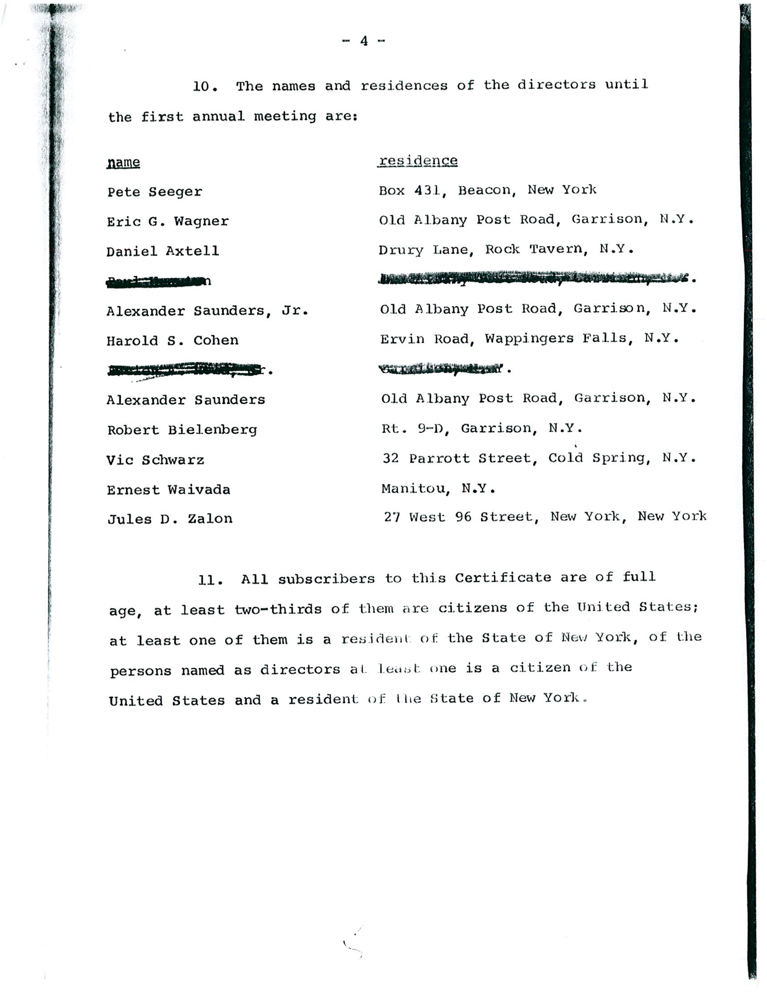
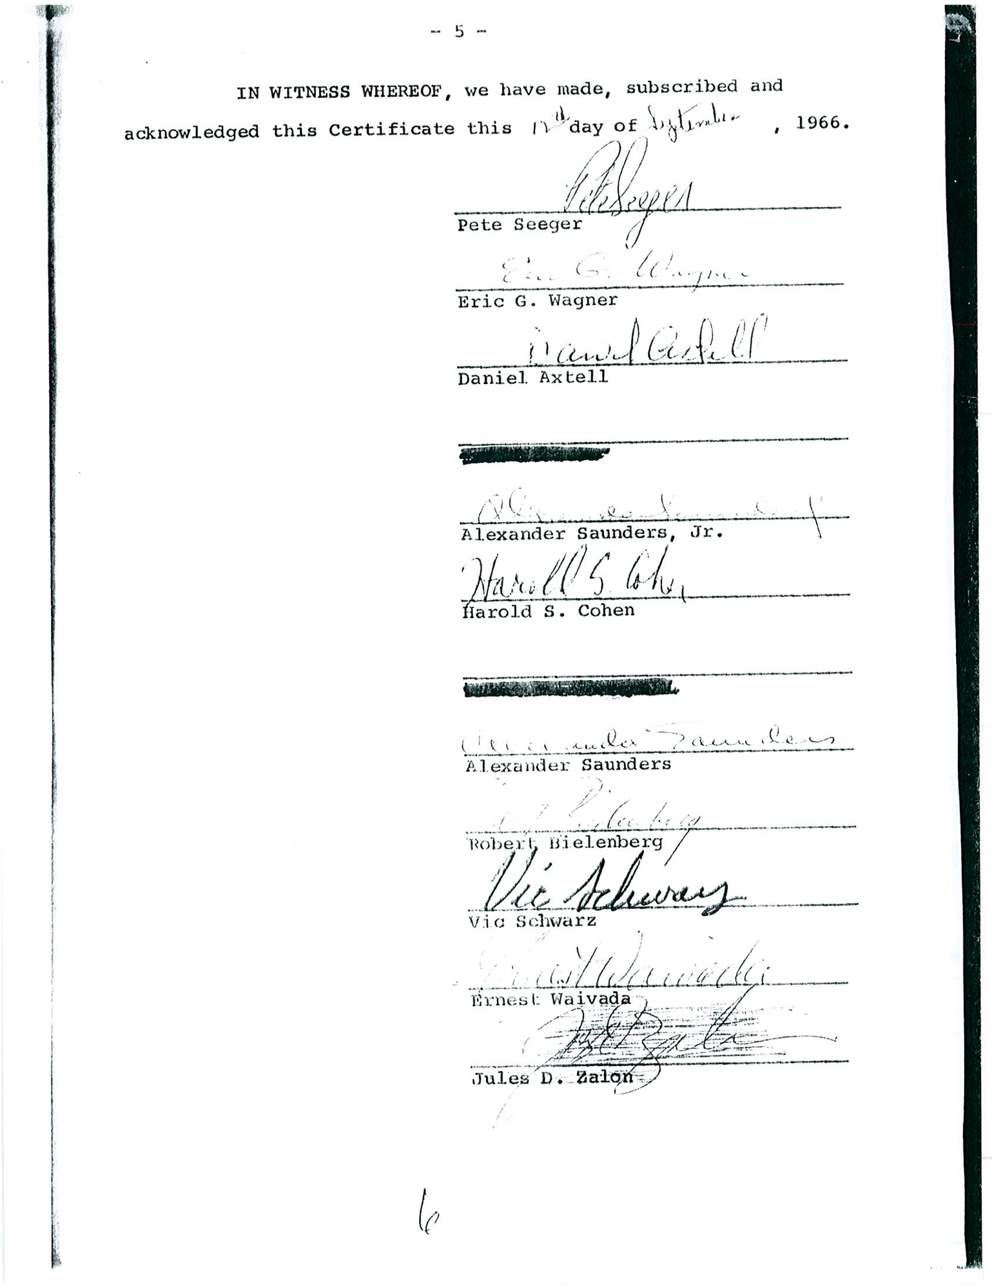
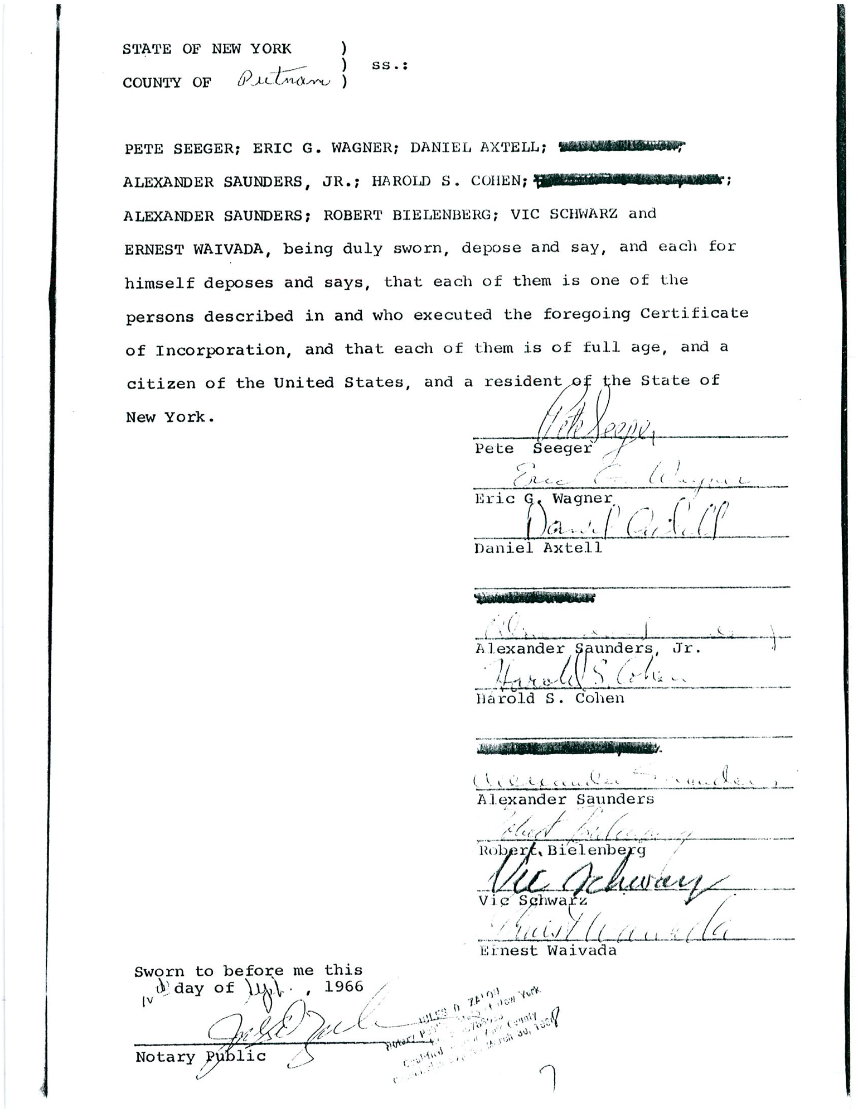
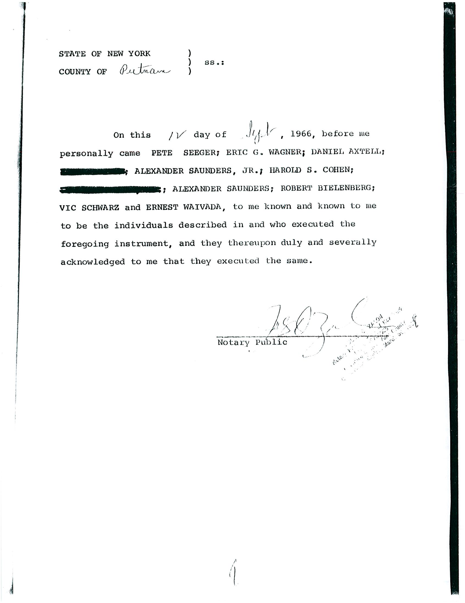
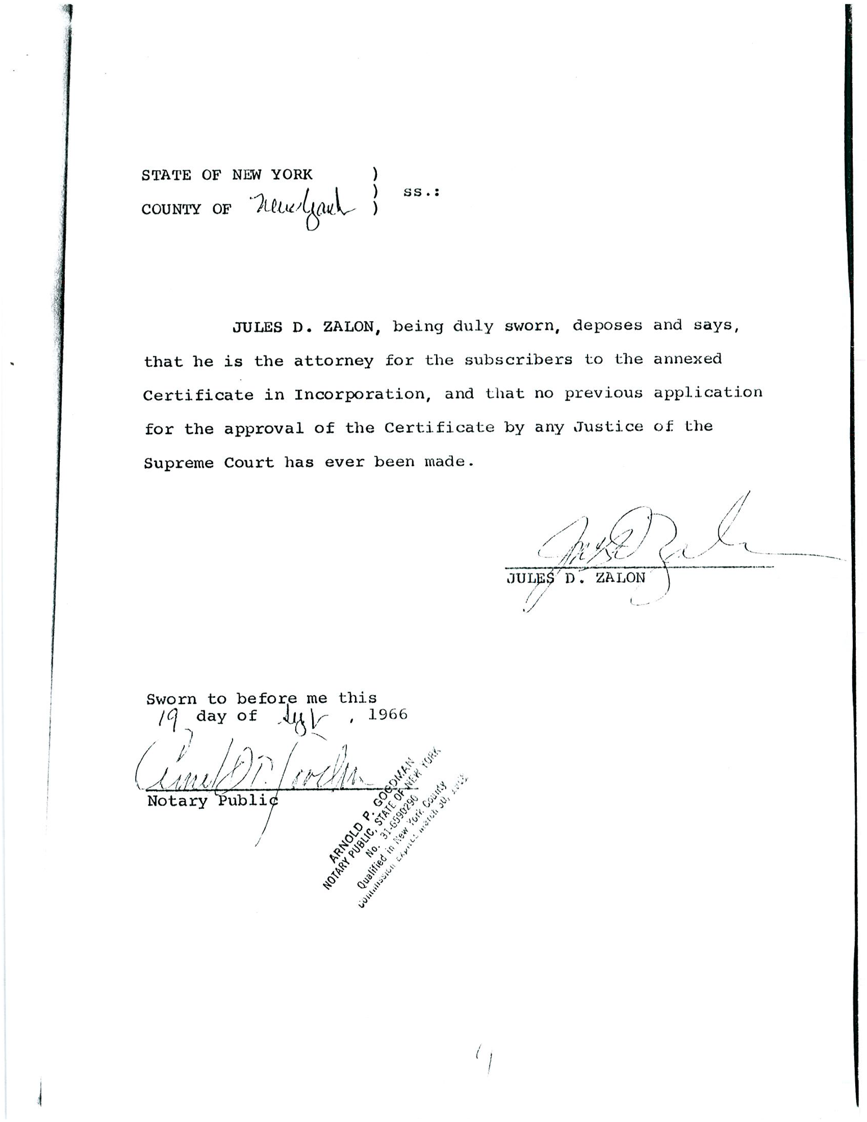
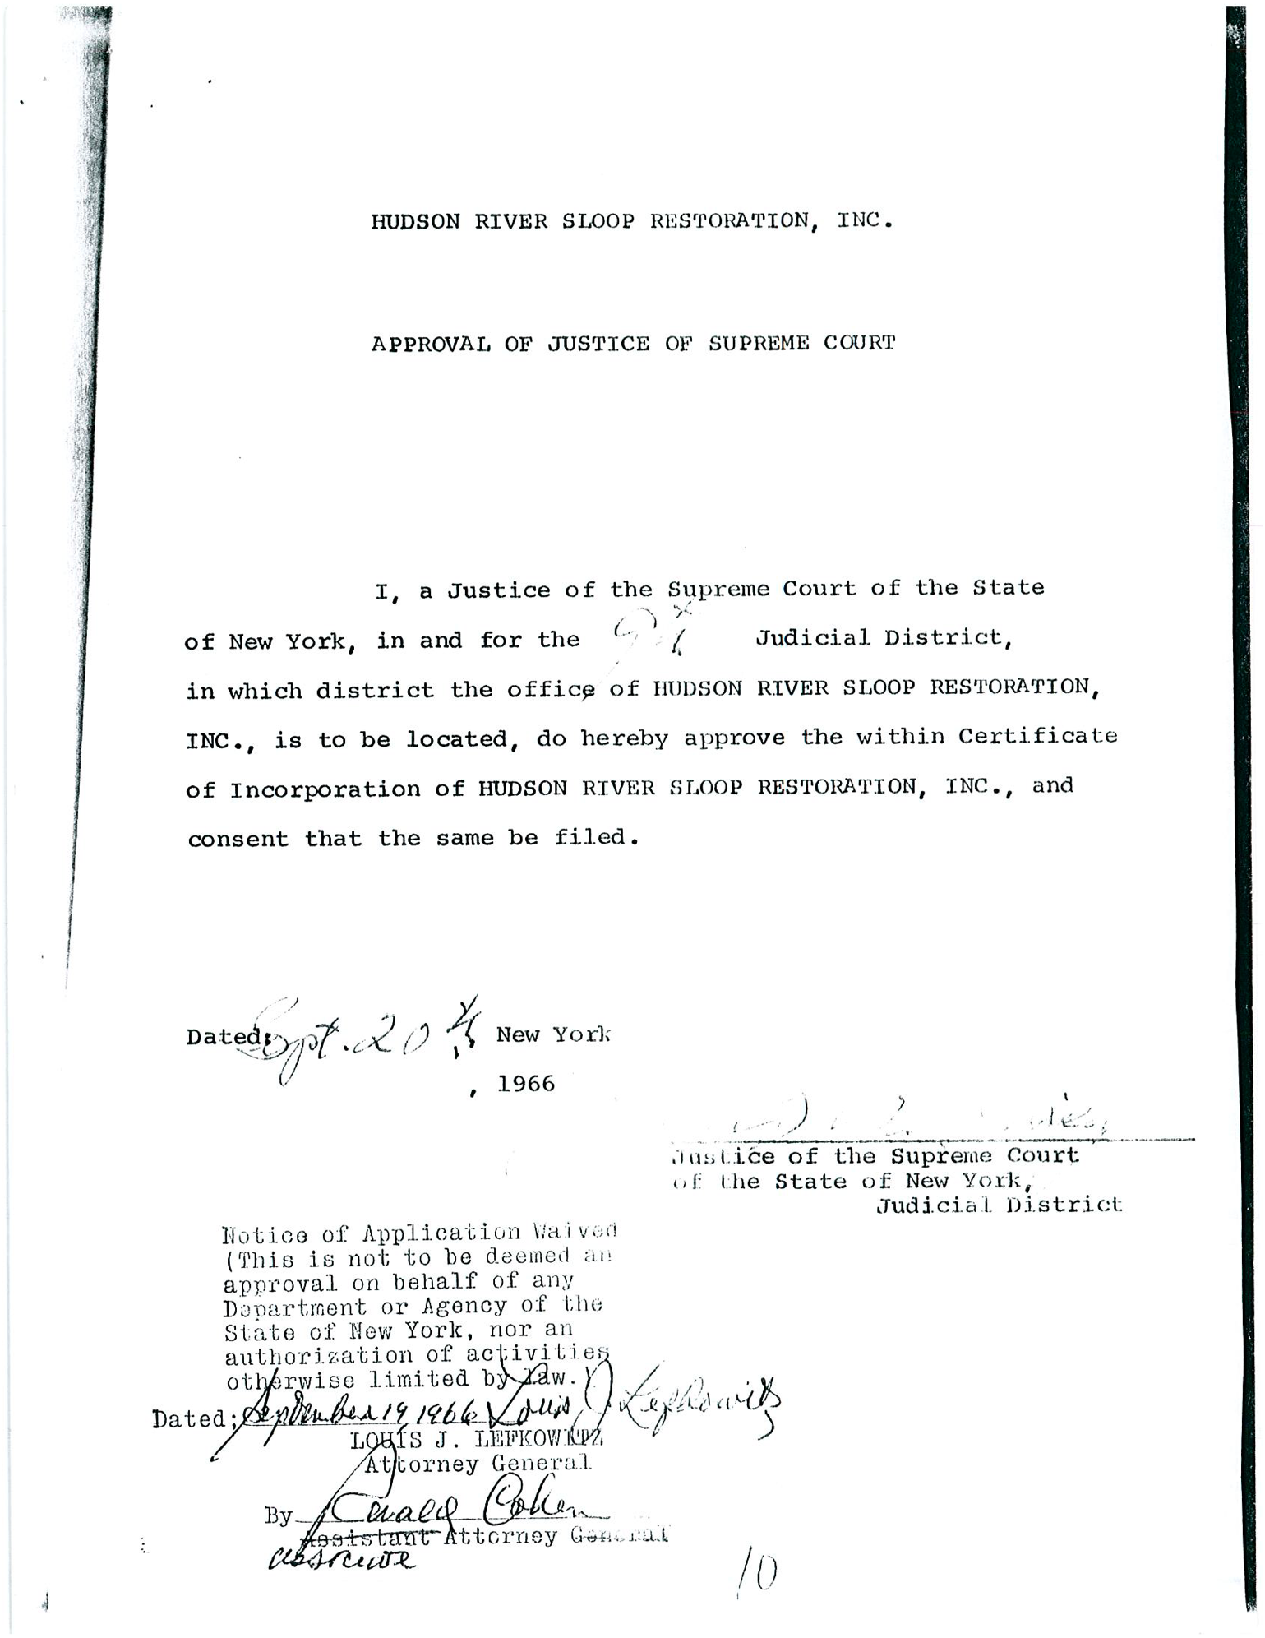
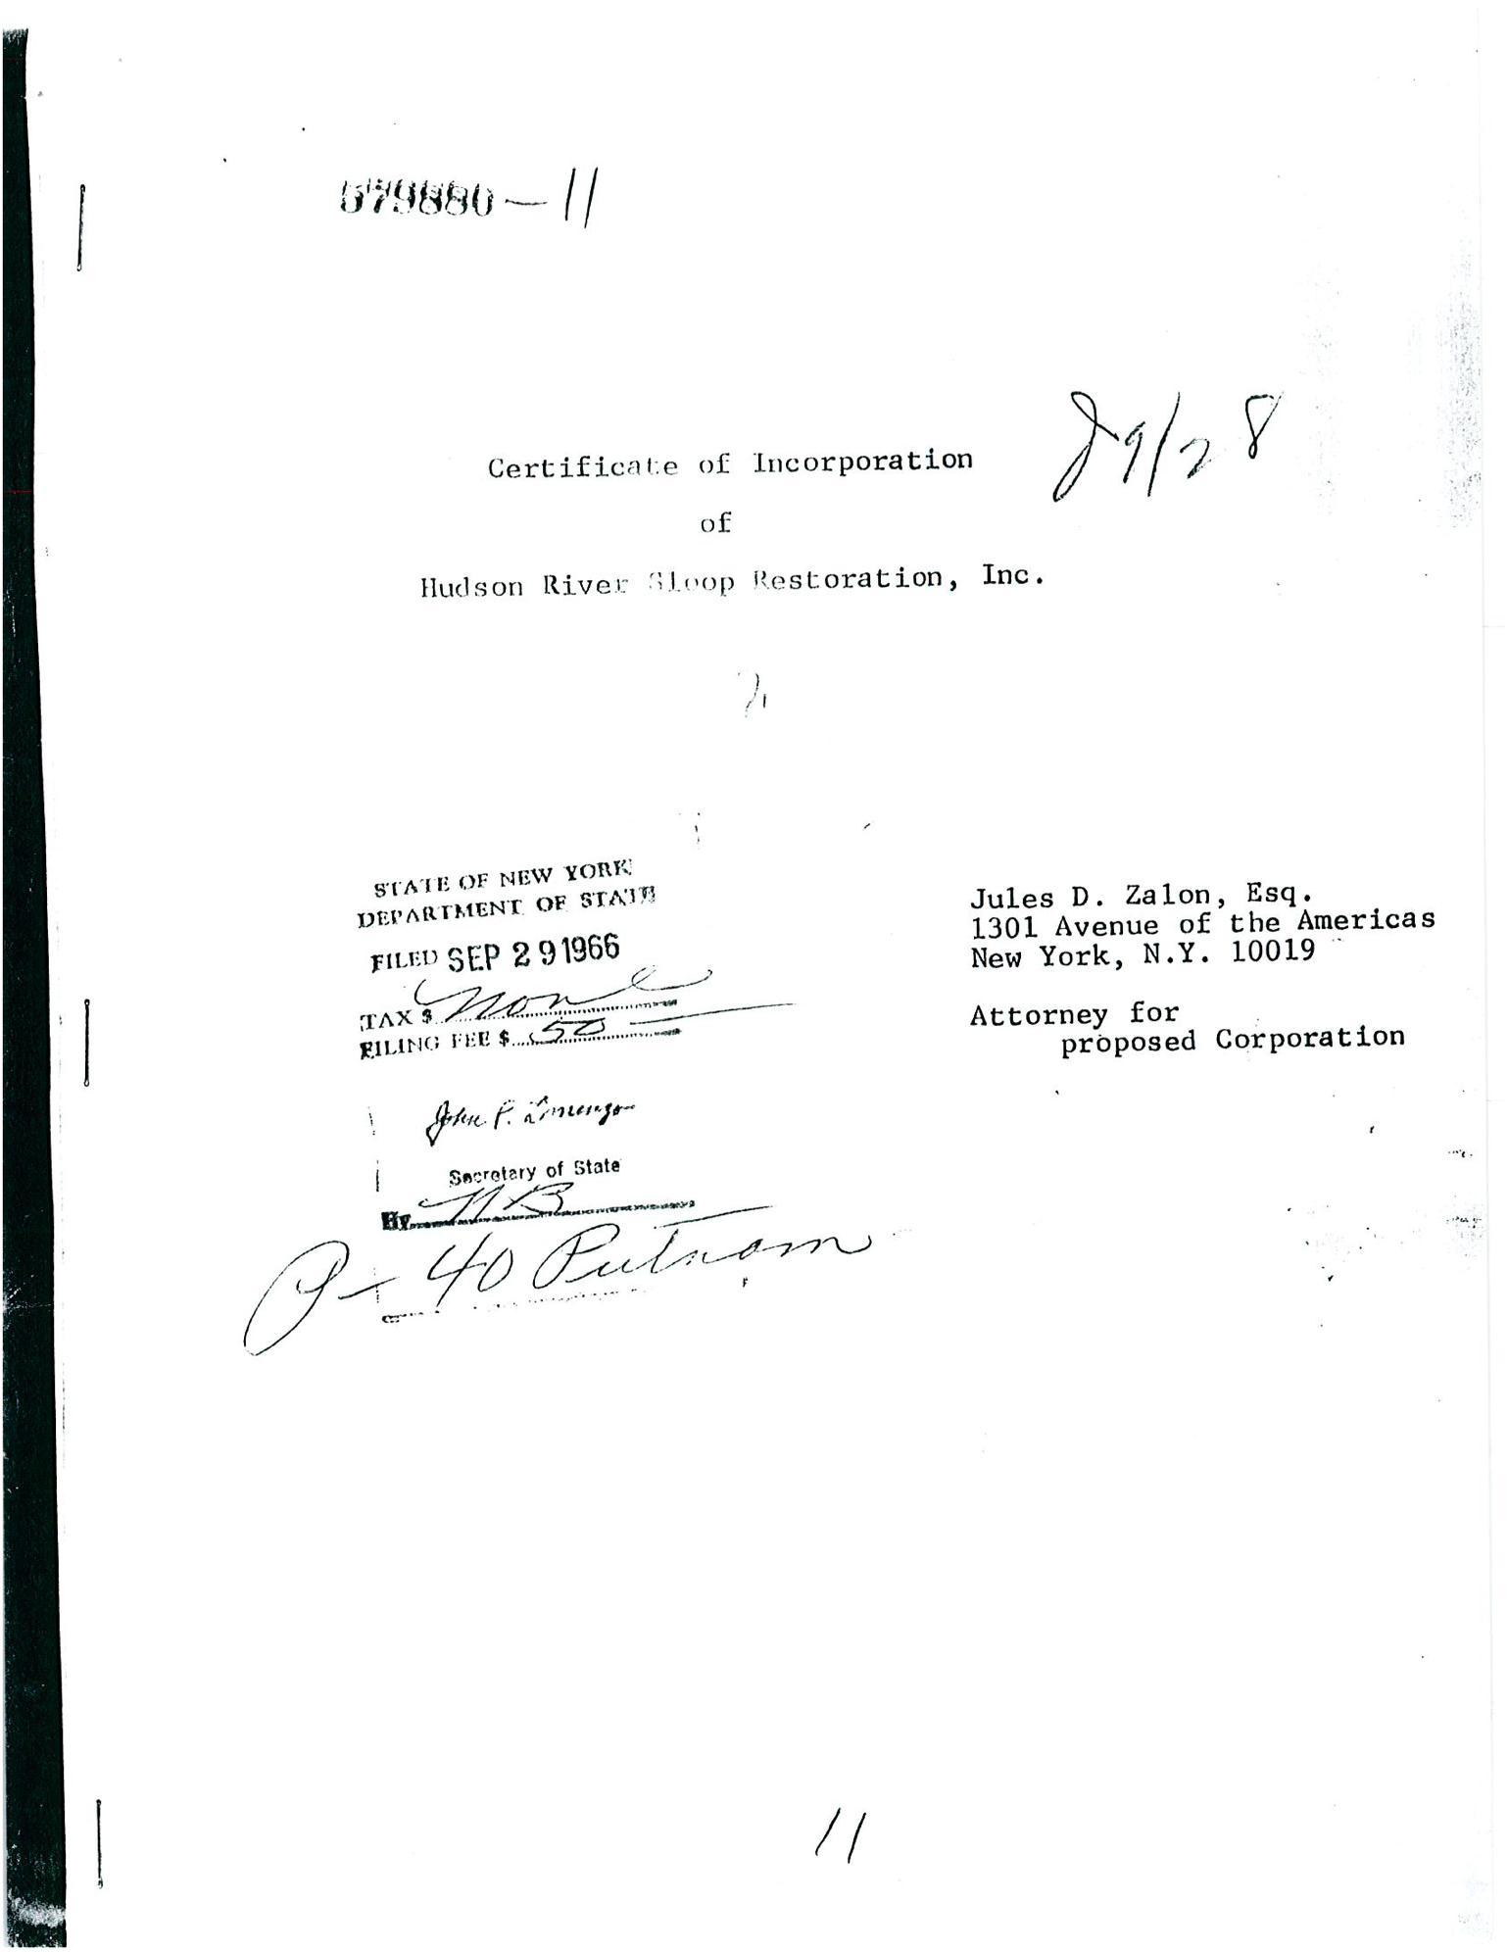

By-Laws of The Hudson River Sloop Clearwater, Inc.

ARTICLE I NAME
The name of the Corporation shall be the HUDSON RIVER SLOOP CLEARWATER, INC.

ARTICLE II PURPOSE
The purpose for which this Corporation is formed, which is to be charitable and no other, is:
To defend and restore the Hudson River, one of the great and historic rivers of this nation; to investigate and conduct research into any cause or sources of contamination and destruction of this river, its tributaries and similar river systems; to inform the public of such dangers and to assist the public in taking such measures as to stop such contamination; to educate the general populace as to the importance of preserving the Hudson River, its tributaries and similar river systems; to foster the historic and cultural heritage of the Hudson River Valley from the mountains to the sea; to concern itself with the well-being of those individuals who dwell along its banks and related areas; to protect and restore other great waterways; and to conduct other actions including, but not limited to, litigation that will enhance and improve the environment of the Hudson River Valley and related areas.

ARTICLE III PLACE OF BUSINESS
The office of the Corporation shall be located in the City of Beacon, County of Dutchess, State of New York, but it may also engage in operations elsewhere in the United States.
(The foregoing Articles, forming part of Incorporation, can be changed only by amending such Articles as provided by law.)

ARTICLE IV MEMBERSHIP
Section 1. The membership of the Corporation shall consist of persons who are interested in advancing the purpose of the Corporation and who pay minimum annual dues, as set from time to time by the Board of Directors. The membership shall control the Corporation through the annual election of Directors.
Section 2. A member may be suspended or removed from the Corporation, or a prospective member excluded, for acts counter to the purpose of the Corporation - after a hearing, if s/he so desires - by a majority vote of the actual membership of the Board of Directors.

ARTICLE V DIRECTORS AND OFFICERS
Section 1. The government of the Corporation shall consist of a body known as the Board of
Directors. The Board of Directors shall consist of up to twenty-five elected members of the
Corporation and any member appointed as Secretary or Treasurer pursuant to Article V, Section 2. In the event that any member of the Board of Directors ceases to serve, a member of the Corporation shall be appointed by the Board to fulfill the unexpired term.
Section 2. The officers of the Corporation shall be a President, Vice President, Secretary and Treasurer. The President and the Vice President must be members of the Board of Directors at the time of their nomination as officers and are to be elected by the Board of Directors. The Secretary and the Treasurer need not be members of the Board of Directors at the time of their nomination, but must be members of the Corporation, and are to be elected by the Board of Directors. If the Secretary or the Treasurer chosen by the Directors is not a Director at the time of nomination, then such officer shall become a duly qualified Director upon election.
Section 3. The Directors shall enter into their term of office upon their election. The Board of Directors shall meet no more than three weeks after the general election, with the election of officers, as specified in Section 2 of this Article, as their first order of business. These officers will serve as officers of the Corporation and of the Board. The presiding officer at this meeting shall be the President, who was duly qualified and elected to hold such an office prior to this election of officers, until a new President is elected.
Section 4. An officer shall hold office for one year and may succeed in that office until a successor is elected and qualified, unless having earlier lost the status of Director.
Section 5. Directors are elected to a term of three years or until three out of four consecutive meetings are missed. Directors are limited to serving three consecutive three-year terms, with an absence of one year required before additional service.
Section 6. The Board of Directors shall be the managing board of the Corporation. It has the power to fill vacancies in the Board and its officers for unexpired terms and act for its interests in any way not inconsistent with these by-laws.
Section 7. The basis for removal of a Director shall be acts which are detrimental to the best interests of the Corporation. A member of the Board of Directors may be suspended or removed from his or her position by a majority vote of the actual and duly qualified membership of the Board after complete discussion by the Board of charges brought against the member. Such member must be afforded the opportunity to be heard by and respond to the Board concerning such charges.

ARTICLE VI DUTIES OF OFFICERS
Section 1. The President shall preside at all meetings of the Corporation and of the Board of Directors; enforce the by-laws and carry out the policies of the Board; call such meetings as prescribed; nominate the chairpersons of all standing committees and present such nominations to the Board of Directors for confirmation; and have such other powers as ordinarily accompany the office.
Section 2. The chief duty of the Vice President is to immediately assume the duties of President, as listed in Section 1 of Article VI, when the President is unable to serve. Under such conditions, the Vice President shall assume the title of “Acting President” until the next meeting of the Board of Directors, when a new President shall be chosen.
Section 3. The Secretary shall keep a current list of the members of the Corporation; keep an exact record of the proceedings of the Board of Directors; have charge of the records of the Corporation; maintain an index and numbered record of all policy statements adopted by the members of the Corporation and the Board of Directors; give notice to the members of the Corporation and to the Board of Directors of meetings of the Corporation and of the Board; keep in safe custody the seal of the Corporation; and when authorized by the Directors, shall affix it to any instrument requiring a seal; and, in the absence of both the President and the Vice President at any meeting, shall call to order and preside over the election of an Acting President for the meeting. The Secretary shall have the authority to delegate such responsibilities as are necessary for the efficient operation of the organization.
Section 4. The Treasurer shall, under the general supervision of the Board, have custody of the monies and investments belonging to the Corporation; shall receive and receipt for membership dues; make disbursements and investments of the Corporation’s funds; keep proper books of account; at all meetings of the Board, annually, and at other times as may be required, submit to the members and the Board of Directors a report of the receipts and disbursements, and the financial condition of the Corporation. The Treasurer shall have the authority to delegate such responsibilities as are necessary for the efficient operation of the organization.

ARTICLE VII COMMITTEES OF THE BOARD
Section 1. The Board shall elect an Executive Committee and two members of a Nominating Committee from the membership of the Board of Directors. The Board may appoint such other standing, ad hoc, and advisory committees as it may deem appropriate.
Section 2. The Executive Committee and the two Board members who will serve on the Nominating Committee shall be elected annually at the same meeting as the election of officers. All other committees may be appointed at the convenience of the Board of Directors.
Section 3. Executive Committee: The Executive Committee of the Board shall consist of the President, Vice President, Secretary, Treasurer, and three other members to be elected by the Directors. The Executive Committee may exercise all powers of the Board of Directors between meetings of the Board, with the exception that the Executive Committee shall not hire or fire employees, unless the Board of Directors specifically delegates such power. The Executive Committee may take binding votes by telephone or e-mail where necessary and appropriate, but only if actual notice of vote is provided in advance to all Executive Committee members and only if a record of the decision is distributed by email to all Board Members promptly following the decision. Decisions of the Executive Committee may also be ratified by the Board of Directors by e-mail or telephone query to all Board Members for time-sensitive matters where necessary and appropriate, but only upon the approval of more than fifty percent of the remaining Board Members following reasonable notice, and only if a record of the decision is distributed to all Board Members by e-mail promptly following the decision. Such actions as are taken by the Executive Committee between Board meetings shall be reported to the Board of Directors at their next meeting, and shall be subject to ratification by the Board. The Executive Committee shall not have the power to take action which will overrule an established policy of the Board. The Board may delegate to, or withdraw from, the Executive Committee such powers as it may determine. If a member of the Executive Committee becomes unable to serve, replacement of such member shall be made in the same manner described in Section 1 of this Article.
Section 4. Nominating Committee: The Board of Directors shall elect two of its members to a
Nominating Committee, who will in turn recommend three additional members from outside the Board to serve on this committee. The three non-Board members recommended for the Nominating Committee must be approved by the Board of Directors at the meeting following the election of the officers. The purpose of this committee is to seek out and nominate qualified candidates for the next election of the Board of Directors. The members of this committee shall serve for a term of one year or until replaced.

ARTICLE VIII NOMINATION OF DIRECTORS
Section 1. The Nominating Committee of the Board of Directors shall be comprised of five members who have been appointed by the Board in accordance with Sections 2 and 4 of Article VII.
Section 2. It shall be the duty of the Nominating Committee to nominate candidates for Directors to fill vacancies on the Board of Directors for the ensuing three-year term. The general membership shall be notified that the Committee is seeking suggestions for nominations. All members of the Corporation are eligible for nomination. Additional nominations may be submitted to the Committee by petition of any five members of the Board of Directors, or any thirty members of the Corporation, up until ten weeks prior to the election.
Section 3. Eight weeks before the annual election, the Nominating Committee shall file its report with the Secretary of the Corporation, the names arranged in alphabetical order, for Board acceptance.
Section 4. A ballot containing the names of the nominees in alphabetical order shall be distributed to each member of the Corporation at least four weeks before the date of the annual election. The ballot shall have two (2) blank spaces for the convenient insertion of additional names.
Section 5. The Nominating Committee must prepare a brief fair statement concerning each nominee, and those statements shall be distributed with the ballots.

ARTICLE IX ELECTION OF DIRECTORS
Section 1. The election of the Directors shall take place at each Annual Meeting of the Corporation. Such election shall be held no earlier than the second Sunday in September, nor later than the third Sunday in October. The voting shall be by secret ballot. A plurality of votes shall elect. Individual members shall each cast one ballot; each adult member of the family covered by a family membership shall cast one ballot. Ties shall be broken immediately after tabulation by a vote taken among members present. Official ballots which are completed and returned to the office of the Corporation by United States Postal Service mail (US Mail) or in such manner as may be specified in instructions distributed with the ballots will be accepted if they are received no later than the day before the election.
Section 2. The Board of Directors shall provide for the appointment from the membership of the Corporation five Judges of Election to supervise said election, and it shall be their duty to count the ballots and tabulate the results and report to the President and Secretary in writing the number of votes cast for each candidate and the names of those elected to serve as Directors. The election of the Directors shall be certified at the Annual Meeting of the Corporation. The Secretary shall thereupon notify in writing the members elected.

ARTICLE X CORPORATION AND BOARD MEETINGS
Section 1. The Annual Meeting of the Corporation shall be held no earlier than the second Sunday in September nor later than the third Sunday in October at a time and place to be fixed at the first meeting of the newly elected Board of Directors at their discretion. All members must be notified of the time, date and location and proposed agenda by US Mail or by email or other electronic means, in accordance with the provisions of Section 2 of ARTICLE XI, below, at least four weeks in advance of Corporation meetings. One hundred voting members of the Corporation shall constitute a quorum.
Section 2. Meetings of the Board of Directors shall be held when called by the President or by seven members of the Board. The Secretary shall mail to each member of the Board a written notice specifying the time and place of the meeting at least seven days prior. Alternatively, notice of Clearwater Board Meetings may be made by e-mail and posting on the Clearwater website, except to a Board Member who requests notification by regular mail. One third of the actual number of Directors shall constitute a quorum for the transaction of business.
Section 3. All meetings of the Board of Directors, the Executive Committee or of any committee thereof, shall be open to attendance by any members of the Corporation in good standing, but nothing herein shall prevent the Board or any such committee, by resolution or other appropriate action, from convening in private session for the consideration of any matter which may come before them, provided the vote or other final action shall be taken in open session.
Section 4. Directors are not permitted to cast proxies or to instruct other Directors to cast proxy ballots.
Section 5. Members of the Board of Directors may, from time to time where necessary fully participate in Board Meetings via telephone conference call, if such technology is available for the meeting. Participation by telephone conference call however, shall not reduce the Board Member’s obligation to be present at the meetings as otherwise required by these Bylaws.

ARTICLE XI BALLOT BY THE CORPORATION
Section 1.Whenever the Board of Directors shall decide that a question submitted for its decision is of such importance that it should be submitted to a vote of the Corporation, the Board shall: submit to the Secretary, in writing, such question, formatted and worded precisely as it is to be finally presented; direct the Secretary to include such question on the regular ballot for comment or direction; or, if the Board should order such a question to be included on the ballot for vote, the Board should direct the Secretary to distribute the ballot and canvass the vote in the same manner as for the annual election of Directors. A majority vote of all ballots shall decide the question. The Board shall upon the written request of fifty members of the Corporation submit to vote any question that they propose.
Section 2. Whenever the Board, the Nominating Committee or the Corporation is required by these Bylaws to distribute a ballot, notification or other document, instrument or communication to the membership or notify the membership of any matter or action, such distribution or notification may be by email addressed to that member at the most recent email listed for that member in the Corporation’s membership records, except that such distribution or notification may not be by email (but shall be by US Mail) to any member who has not been notified in person or by US Mail that he or she has the option of receiving communications and notifications by US Mail or to any person who has elected that option. Members retain the right to change their option upon due notice.
Section 3. Whenever a communication, including a completed ballot, is to be sent or conveyed by a member to the Corporation pursuant to these Bylaws, such communication may be made either by US Mail or at the option of the member by email or other electronic means established and authorized by the Board for such purpose, provided that the Corporation has notified the member (by US Mail or email, in accordance with Section 2 of this Article XI) of the email address or other means so established for such purpose.
Section 4. In the case of any communication by members to the Corporation that, under these Bylaws, constitutes a vote by the membership, the Board shall authorize a means of email or other electronic voting only if the Board is satisfied that such means includes functionality designed to prevent duplicate and unauthorized balloting. Furthermore, in the case of any communication by members to the Corporation that, under these Bylaws is to be by secret ballot, the Board shall authorize a means of email or other electronic voting only if the Board is satisfied that such means affords members either the ability to submit such ballots anonymously or the ability to submit them to a third party designated and deemed trustworthy by the Board, which third party will tabulate the results and report them to the Judges of Election (without disclosing the votes of individual members), who in turn will combine such votes with those received through the US Mail and include them in the report to the President and Secretary delivered by the Judges of Election pursuant to Section 1 of Article IX, above.

ARTICLE XII AMENDMENTS
Amendments to these by-laws may be proposed by petition of any five members of the Board of Directors or any fifty members of the Corporation. If such an amendment is approved by the Board, it shall be submitted to the Corporation for a referendum vote. Such a vote could take place at the same time as the election of the Board, or at any other time set by the Board, and in accordance with the procedures set forth in Article XI. If approved by two-thirds of those voting, such amendment will become part of these by-laws.

ARTICLE XIII SLOOP CLUBS
Section 1. Members of the Corporation who reside in the same region may apply for recognition as a Sloop Club. The Board of Directors, when satisfied that the purpose of the Corporation will be served by the proposed Sloop Club, shall grant it a charter at the next immediate Annual Meeting for a period of one year. A Sloop Club shall act in accordance with the policies of the Corporation, with the understanding that the purpose of this requirement is to attain general unity rather than absolute control.
Section 2. Each Sloop Club may, at the discretion of the Board of Directors, have its charter renewed for a period of one year at the Corporation’s Annual Meeting. Each Club shall satisfactorily demonstrate its ability to maintain standards set by the Sloop Club Review Committee, which shall be appointed by the Board of Directors. The structure and functioning of the Club, including its relations with the Corporation, shall be governed by rules adopted from time to time by the Board of Directors.
Section 3. A Sloop Club may have its recognition removed by a vote of two-thirds of the actual membership of the Board of Directors. The Sloop Club will be entitled to a hearing, if one is so desired, prior to such a vote.
Section 4. No Sloop Club shall be recognized unless an application signed by at least ten members of the Corporation, all residents of the designated region, shall have been filed with the Board. The application shall propose the geographical boundaries and the name chosen by the applicants. If the proposed boundaries include territories already assigned to an existing Sloop Club, the application must be accompanied by a waiver duly authorized by said Sloop Club.
Section 5. As soon as the formation of a Sloop Club has been recognized by the Board of Directors, the Secretary shall provide to the Club a list of the names of all members who reside in the designated territory.
Section 6. Each Sloop Club shall elect two individuals to attend meetings of the Board of Directors of the Corporation. Each Sloop Club may cast one advisory vote on all matters which come before the Board of Directors.

ARTICLE XIV ADMINISTRATIVE DUTIES
Section 1. The day-to-day operations of the Corporation may be entrusted to full-time paid administrative employees who will carry out the policies established by the Board of Directors.
Section 2. The senior administrative employee, whose prime function shall be to implement the policies established by the Board of Directors and the Executive Committee, shall be known as the Executive Director. The Executive Director shall be nominated and approved by a majority vote of the Board of Directors. The Executive Director shall be paid a salary set by the Board of Directors.
Section 3. The Board of Directors has the authority to hire and fire all employees of the Corporation, but it shall have the right to delegate this authority. Employees who are terminated can appeal to the Board in accordance with the procedures prescribed in the Employee Personnel Policy which has been approved by the Board of Directors.
Section 4. No person who is a paid employee of the Corporation, or any of its subsidiaries or related bodies, shall be eligible to serve as a member of the Board, but the Board may request them to attend meetings to help set policies.
Dated: September 26, 1987, as amended June 1993, and as further amended April 1995 and further amended April 1998. Further amended October 2002 and further amended October
2005. Further amended September 27, 2009. Further amended September 17, 2011 and further amended September 24, 2016.

Policies of The Hudson River Sloop Clearwater, Inc.

Policy I. General Policies on Executive Director Limitations of the Not-for-Profit Corporation Hudson River Sloop Clearwater, Inc.
As an overriding principle, the affairs of the Corporation shall be conducted within generally accepted and business-like standards of safety, prudence, ethics and legality. The Executive Director acts at the pleasure of the Board of Directors as the Chief Executive Officer of the Corporation, freely when within the following limitations:

I. Financial Support:
- With respect to the sources of funds, donations and memberships, the Executive Director will not without consulting with either the Board at a regularly scheduled meeting or in an emergency with the President of the Board:

  - Seek funds in a manner that will compromise the mission or image of the Corporation.

  - Make agreements or obligate Clearwater to comply with donor constraints other than for normal and customary dedication associated with restricted donations to specific programs, activities, capital projects, etc.

  - Initiate or engage in merchandising opportunities inappropriate to the purpose of the organization or in conflict with the policies outlined herein.

  - Use funds from the restricted contributions for any purpose other than that required by the contribution without prior assent by the funding source.

- With respect to fiscal management and fiduciary responsibility, the Executive Director will not without consulting with either the Board at a regularly scheduled meeting or in an emergency with the President of the Board:

  - Incur debts or other obligations, or extend credits or funds, other than for short-term trade payables or receivables.

  - Use cash, instead of checks, as payment for goods or services except for normally recognized petty cash expenses of less than $100; enter into a contract for goods or services in excess of $5,000 per annum or in excess of three years; maintain funds in bank accounts other than those authorized by the Board; allow
other than prompt deposits of funds received into appropriate bank accounts; invest in funds in accounts other than those insured by FDIC, MBIA or other equivalent insurance; or deviate from Board investment policy.

  - Purchase goods or services from any individual or organization where there might exist the appearance of a conflict of interest or less than an “arms length transaction.”

  - Permit insurance coverage to lapse or otherwise fall below a level necessary for prudent risk management and asset replacement.

  - Commit to plans, programs or expenses that exceeded the total annual budget or individual budget categories of the annual budget, unless such expense overages are offset by revenue overages or by expense savings elsewhere in the budget; or permit revenues to fall below budget unless such revenue shortages are off-set by expense savings.

  - Allow cash liquidity to fall below levels necessary to maintain normal operations and meet anticipated obligations.

  - Permit budgets or financial statements to contain too little information for reasonably accurate projections of revenue and expense, separation of capital and operational items, cash flow and subsequent audit trails.

  - Prepare regular monthly financial reports to the Board on any basis other than accrual accounting in compliance with Generally Accepted Accounting Principles (GAAP).

  - Permit disorganization of financial documents (invoices, deposit records, etc.) or fail to maintain financial records for at least seven years from the current period, such that the affairs of the Corporation cannot be audited by independent auditors and government agencies.

II. Personnel Policies and General Administration

With respect to personnel policies and administration, the Executive Director shall not without consulting with either the Board at a regularly scheduled meeting or in an emergency with the President of the Board:

- Deviate from the personnel policy in managing the staff.

- Permit any staff member to operate in his or her job for more than three months without a job description.

- Permit any staff member or employee to engage in activities related to their employment in an unprofessional or unsafe manner.

- Discriminate in any way or permit discrimination by any staff member against an employee on the basis of age, sex, race, religious affiliations, sexual orientation, gender identity or expression, disability or veteran status.

- Operate without clear and documented plans and procedures, known and available to employees, to insure operational and administrative continuity.

- Operate without clear and documented descriptions for delegation of responsibility and authority.

III. Real Estate, Tangible and Intangible Property

With respect to maintenance of the real estate, tangible and intangible property of the Corporation, the Executive Director shall not without consulting with either the Board at a regularly scheduled meeting or in an emergency with the President of the Board:

- Allow the premises at 112 Little Market Street, Poughkeepsie, NY or other tangible property of the Corporation, such as motor vehicles or merchandise inventory, to fall into a state of disrepair or to violate any applicable local, state or federal law, code or regulation.

- Allow the premises at 112 Little Market Street, Poughkeepsie, NY or other physical assets of the Corporation, to be maintained in a manner that might jeopardize safety or reflect adversely on the image of Clearwater.

- Move or expand the physical location of the Clearwater office from 112 Little Market Street, Poughkeepsie, NY.

- Delay or postpone the immediate notification of the President of the Board or his/her designee of proposals or opportunities to acquire real property or other material assets, to sell or encumber real property or other material assets, or to make capital improvements, repairs, alterations or changes to real property or material assets.

- Fail to protect the Corporation’s rights in its intangible assets such as copyrights, trademarks or goodwill.

IV. Sloop

With respect to the operation of the sloop Clearwater or other vessels, the Executive Director shall not without consulting with either the Board at a regularly scheduled meeting or in an emergency with President of the Board:

- Permit the sloop to fall below the standards for a vessel of its type as set by the United States Coast Guard, or into a state of disrepair.

- Permit the sloop to be operated in a manner that would violate United States Coast Guard or other regulations and/or jeopardize the safety of the boat, crew or its passengers.

- Allow the sloop to operate in any manner inconsistent with the mission of the organization or for commercial purposes.

- Cause or permit the sloop to operate outside the waters approved by our license with the United States Coast Guard.

V. Legal

With respect to legal issues and actions, the Executive Director shall not without consulting with either the Board at a regularly scheduled meeting or in an emergency with President of the Board:

- Permit initiation of withdrawal from, or appeal of an adverse decision from any civil or criminal legal action, alone or in concert with others without the prior and continuing approval of the Board of Directors with the following specific exception:

[The Executive Director may immediately press appropriate charges upon the commission of any felonious or criminal acts against any persons involved in Clearwater activities or the property and equipment of the Corporation, subject only to the subsequent notification as quickly as possible of the President of the Board of Directors or his/her designee.]

- Delay or postpone the immediate notification of the President of the Board or his/her designee should any member of the staff or a volunteer be charged with or arrested as a consequence of any act or action in conjunction with his/her relationship with the organization.

- Delay or postpone the immediate notification of the President of the Board or his/her designee should any civil or criminal action be initiated, terminated, appealed or have a decision rendered in which Clearwater, or persons acting on behalf of Clearwater are named as either plaintiff, defendant or witness.

VI. Purpose and Direction

With respect to representing the Hudson River Sloop Clearwater, its purpose and direction, the Executive Director will not without consulting either the Board at a regularly scheduled meeting or in an emergency with the President of the Board:

- Fail to comply with the by-laws of the Corporation or with any federal, state or local law or regulation applicable to the
Corporation including, but not limited to, restrictions applicable to not-for-profit corporations under Section 501(c)(3) of the U.S. Internal Revenue Code.

- Make statements or permit employees to make statements about individuals or entities that may be construed as libelous or inflammatory and that are not founded in factual data that can be confirmed by two independent sources.

- Make statements or give positions that endorse a political party or an individual running for public office.

- Affiliate with other organizations for purposes other than the primary purposes and mission of the Hudson River Sloop Clearwater or with organizations whose makeup and/or practices may reflect negatively on the Hudson River Sloop Clearwater.

- Permit the organization, its assets or employees to engage in advertising for commercial enterprises or in commercial ventures with other entities in a manner that may compromise the purpose of the organization or reflect poorly on its programs or affiliations.

- Delay or postpone the immediate notification of the President of the Board or his/her designee of trends, public events and other material matters that change or modify the assumptions under which Board policy is established.

- Terminate major programs.

1/22/95
Adapted 11/04
Adapted 11/06 ALP Amended 10/18 PGC

Policy II. Policies on Board of Directors - Executive Director Relationship of the Not-for-Profit Corporation Hudson River Sloop Clearwater, Inc.

I. Delegation to the Executive Director

- It is the responsibility of the Executive Director to implement the policies and attain the organizational ends established by the Board of Directors.

- The Executive Director is free to create, amend and modify the mechanisms by which the Board policy is implemented by whatever means he/she sees fit, provided that the means do not violate any prescriptions set forth in the Board’s policies on Executive limitations.

- All Board authority to delegate to the staff is delegated through the Executive Director, and the Board will officially relate to the staff only through the Executive Director.

- The Executive Director is accountable only to the Board as a whole. Permanent Board information will be presented to the Executive Director in the form of policy statements representing the intentions of the Board as a whole.

- The Executive Director is accountable for the performance of Clearwater as a whole; for the actions of Clearwater’s employees and volunteers; and for the public perception of Clearwater.

II. Monitoring and Evaluating Executive Performance

- The Board shall monitor the performance of the Executive Director to determine whether Board policies are being adhered to and limitations are not being violated.

- The Executive Director shall be evaluated annually, prior to and within one month of the annual meeting, and at such additional times as the Board determines are appropriate and necessary.

- Monitoring and evaluating the overall performance of the Executive Director is the responsibility of the Executive Committee of the Board of Directors.

- The Executive Committee may request such information from the Executive Director, as it deems necessary to perform its monitoring function. The Executive Committee may seek input from other Board members and/or may appoint other Board members or outside experts to assess attainment of certain ends or compliance with certain policies.

- Adherence to policies of the Board shall be monitored by the methods set forth below, which shall include periodic internal reports prepared by the Executive Director; direct inspection by the Executive Committee or its designees; and external assessments by auditors and other outside experts qualified in certain technical or policy disciplines. The frequency of monitoring shall be determined by the Executive Committee, but shall be at least annually.

Policy |  |  |  |  | Method of Monitoring | Frequency
  End goals of the
 |  | organization
Defending & Restoring the River and its Watershed |  |  |  |  | Report and Inspection | Annual
Educating the General Populace |  |  |  |  | Report and Inspection | Annual
Fostering Historic & Cultural  Heritage |  |  |  |  | Report and Inspection | Annual
Ensuring Stable and SelfSustaining Organization |  |  |  |  | Report, Inspection and Audit | Annual
Executive Limitations

Financial Support |  |  |  |  | Report, Inspection and Audit | Annual
Personnel Policies and General Administration |  |  |  |  | Report and Inspection | Annual
Real Estate and Other Property |  |  |  |  | Report and Inspection | Annual
Sloop |  |  |  |  | Report, Inspection and Audit | Annual
Legal |  |  |  |  | Report and Inspection | Annual
Purpose and Direction |  |  |  |  | Report, Inspection and Audit | Annual

02/12/1995
Adapted 11/04
Adapted 11/06 ALP

Policy III. Policies of the Not-for-Profit Corporation Hudson River Sloop Clearwater, Inc. Regarding Board of Directors’ Job Responsibilities

I. Board Accountability

The Board accepts accountability for:

- The connection between Clearwater and its moral owners.

- Developing written governing policies defining the following:

  - Clearwater’s goals and objectives
  - The delegation of authority and executive limitations applicable to the Executive Director
  - The process of monitoring and evaluating Executive Director performance
  - The governance process by which the Board carries out its tasks

- Organizational and staff performances via Executive Director limitations and evaluation.

- The prudent fiscal management of the Corporation, including offering assistance with fundraising.

- Periodic self-assessment.

II. The Conduct of Board Meetings

The Board conducts its meetings according to the following principles:

- Meetings are open to the public except when executive session is declared by the President. Such executive sessions are generally limited to matters related to personnel, litigation, or financial transactions where premature disclosure may jeopardize Clearwater’s interests. Votes or other final actions of the Board shall be taken in open session.

- Any Board member may request an executive session, but

  - The justification must be stated.
  - The Board may decide who else, if anyone, may be included.
  - Authority to declare the session is vested in the President unless overridden by a simple majority of board members present.
  - An announcement of the executive session should be made in the published agenda, wherever possible.

- The Board is the sole authority over its own agenda. The President, with the assistance of the Executive Committee, will exercise this control on behalf of the Board, but any Board member can add or delete business from the agenda if a majority of the Board agrees. Material related to the agenda will normally be given to Board members with adequate lead time for review.

- The Board shall deliberate on only those issues that are within the Board’s chosen areas of responsibility.

- Board members are obligated to prepare for meetings by appropriate review of relevant information; to make every reasonable effort to attend meetings and to arrive on time; to participate productively in discussion within the ground rules of discipline established but the Board; and to honor any commitments undertaken.

- The Board adopts the following rules of discipline for its meetings. Members are expected to:

  - Offer honest opinions in a constructive way.
  - Act with respect and consideration for other Board members and for different points of view.
  - Maximize group productivity by focusing on the issues at hand, avoiding unnecessarily long or redundant remarks, and otherwise adhering to the rules of order established by the presiding officer or chairperson.

- The Board encourages the expressions of diverse opinions during the process of deliberation, but speaks with one voice once decisions have been made.

III. Termination of Board Membership

In accordance with Article V, Section 5 of Clearwater’s by-laws, directors are elected to a term of three years, or until three of four consecutive meetings are missed. Members may not serve more than three consecutive three-year terms. Section 7 further provides that a Director may be suspended or removed by Board vote for acts which are detrimental to the best interest of the Corporation.

IV. Responsibilities of Officers

- The President shall preside at all meetings of the Corporation and of the Board of Directors; enforce the by-laws and carry out the policies of the Board; assure the integrity of the Board process, including effectiveness of meetings and the Board’s adherence to its own rules; call such meetings as prescribed; nominate the chairpersons of all standing committees and present such nominations to Board for confirmation; and have such other powers as ordinarily accompany the office. The President is the symbol of the Board and its spokesperson, the person to whom other Board members are accountable for assigned responsibilities, and the principal supervisory contact for the Executive Director.

- The Vice President assumes the functions of the President when the President is unable to serve. Other specific functions may be assigned by the President or the Board.

- The Secretary takes or is responsible for the taking of minutes at meetings of the Board and the Executive Committee; the keeping of Corporate records and minutes; and providing notice to the members of the Corporation and of the Board of Directors of meetings of the Corporation and of the Board. These minutes will be published in draft form on the Clearwater.org web site as soon as practical following the meeting, and following review by at least one other Board member. Proposed corrections will be accepted via the Secretary’s e-mail address of record until the commencement of the following board meeting. The agenda for each meeting shall also be posted on the Clearwater.org web site proximate to the time it is distributed to the Board prior to the meeting. The Secretary shall have authority to delegate such responsibilities as are necessary for the efficient operation of the organization. The Secretary shall formally attest, by signature and or seal, to the legitimacy of the Board and Corporate documents, and shall be responsible to the Board for noting and reporting any inconsistencies in Board actions and adherence to the by-laws. In the absence of both the President and the Vice President, at any meeting, the Secretary shall call to order and preside over the election of an acting President for the meeting.

- The Treasurer shall, under the general supervision of the Board, have custody of the monies and investments belonging to the Corporation; shall receive and receipt for membership dues; make disbursements and investments of the Corporation’s funds; keep proper books of account; submit reports of receipts and disbursements and the financial condition of the Corporation at all meetings of the Board, annually, and at other times as may be required. The Treasurer analyzes ongoing fiscal reports, monitors governmental compliance, links the Board to the financial status and records of the organization, and reports to the Board compliance. The duties of the Treasurer will neither lessen nor add to the Executive Director’s strict accountability to the Board policies on fiscal conditions and budgeting. The treasurer shall have the authority to delegate such responsibilities as are necessary to the efficient operation of the organization.

V. Board Committees

- Board committees may not speak or act for the Board except as permitted under the by-laws with respect to the Executive Committee, or when formally delegated such authority for specific purposes.

- Board committees are to help the Board do its job, rather than to help the staff do its job. Committees will assist the Board primarily by preparing policy alternatives and implications for the Board deliberation and evaluating organizational performance.

- It is recognized that, from time to time, Board members may wish to serve as volunteers within the organization or as participants in staff committees. Such members have the same status as other volunteers and serve under the direction and authority of the staff.

3/19/95
Adapted 11/04
Adapted 11/06 ALP
Adopted 10/18 PGC

Policy IV. Policies of the Not-for-Profit Corporation Hudson River Sloop Clearwater, Inc. Regarding Recruitment and Nomination of Board of Director Candidates

1. Recruitment & Nomination of Directors

A. The general duties and obligations of the Nominating Committee and the individuals eligible for candidacy are stated in the by-laws (Article VII, Section 4 and Article VIII, Section 2):
The Board of Directors shall elect two of its members to a Nominating Committee, who will in turn recommend three additional members from outside the Board to serve on this committee. The three non-Board members recommended for the Nominating Committee must be approved by the Board of Directors at the meeting following the election of the officers. The purpose of this committee is to seek out and nominate qualified candidates for the next election of the Board of Directors. The members of this committee shall serve for a term of one year or until replaced.
(Article VII, Section 4)

The Board members who serve on the Nominating Committee shall act as co-chairpersons of the committee. The Executive Director may advise and assist the Nominating Committee in an ex officio capacity.

It shall be the duty of the Nominating Committee to nominate candidates to fill vacancies on the Board of Directors for the ensuing three-year term. The general membership shall be notified in the Navigator (and Sloop Clubs shall be notified by a letter) that the Committee is seeking suggestions for nominations. All members of the Corporation are eligible for nomination. Additional nominations may be submitted to the Committee by petition of any five members of the Board of Directors, or any
thirty members of the Corporation, up until ten weeks prior to the election.
(Article VIII, Section 2)

- The Nominating Committee shall endeavor to select candidates that will most effectively accomplish the ends, as defined in the policies of the Board of Directors, to promote Clearwater’s purpose as stated in Article II of the by-laws below:

The purpose for which this Corporation is formed, which is to be charitable and no other, is:

To defend and restore the Hudson River, one of the great and historic rivers of this nation; to investigate and conduct research into any cause or sources of contamination and destruction of this river, its tributaries and similar river systems; to inform the public of such dangers and to assist the public in taking such measures as to stop such contamination; to educate the general populace as to the importance of preserving the Hudson River, its tributaries and similar river systems; to foster the historic and cultural heritage of the Hudson River Valley from the mountains to the sea; to concern itself with the well-being of those individuals who dwell along its banks and related areas; to protect and restore other great waterways; and to conduct other actions including, but not limited to, litigation that will enhance and improve the environment of the Hudson River Valley and related areas.
(Article II)

- The Nominating Committee shall seek candidates who are diverse in terms of their race, religion, ethnicity, gender, age, sexual orientation and without regard to disability. The Committee shall also strive to build a board that represents varying community affiliations, professional backgrounds and geographic locations.

- At the beginning of this process there shall be a preliminary discussion involving the Executive Committee, Executive Director and Nominating Committee. These parties shall discuss qualities and attributes needed on the Board for the subsequent year, in addition to the requirements in Items B and C above. Two months prior to presenting the Board with a final slate of candidates, the Nominating Committee shall present a list of potential candidates with their resumes to the Board to elicit Board input and comment.

- To assist potential candidates in understanding the nature of the commitment they may be undertaking, the Nominating Committee shall initially distribute a package of information to all potential candidates which shall include a general description of Clearwater and active Board committees, a basic outline of Board member obligations and the Board’s current meeting calendar. At an advanced stage of the recruitment process, those candidates under serious consideration shall be presented with the Board manual and briefed on the responsibilities of Board membership.

- The re-nomination of interested incumbent Directors shall be presumed with two exceptions. First, an incumbent shall not be re-nominated if the Director is ineligible for re-nomination based upon the six-year term limitations imposed in Article V, Section 5. Second, an incumbent Director shall not be re-nominated if such Director is not acting effectively to promote Clearwater’s purpose as stated in Article II of the by-laws or is
not satisfying the requirements of the job descriptions for Board members as set forth in the written policies of the Board. This determination shall be made by the Nominating Committee based upon the re-nomination of the Executive Committee and Board members of the Nominating Committee. Prior to making an adverse recommendation, the Executive Committee and Board members of the Nominating Committee or a member representing them shall first meet with the Director in question to discuss the situation. The Director shall be notified of the recommendation as soon as is reasonable possible.

2. Timetable for the Nomination and Election of Directors (Article VIII, Sections 3-5)

- All Board members whose terms are due to expire during the current year and who are eligible for re-election shall notify the Nominating
Committee by the beginning of February as to whether or not they wish to be considered for an additional term.

- Ten weeks before the annual election, the Nominating Committee shall file its report with Secretary of the Corporation, the names arranged in alphabetical order. (Section 3)

- A ballot containing the names of the nominees in alphabetical order shall be printed and mailed to each member of the Corporation at least six weeks before the date of the annual election. The ballot shall have two (2) blank spaces for the convenient insertion of additional names. (Section 4)

- The Nominating Committee must prepare a brief fair statement concerning each nominee upon contacting nominees, and those statements shall be printed and enclosed with the ballots. (Section 5)

- In addition to filing its report containing the slate of candidates to the Secretary ten weeks prior to the election, the Nominating Committee shall also present the slate of candidates to the Board along with a resume for each candidate statement.

4/23/95
Adapted 11/04 KCS
Adapted 11/06 ALP

Policy V. Policies of the Not-For-Profit Corporation Hudson River Sloop Clearwater, Inc. Regarding the Orientation and Training of Board Members

In the interest of fostering a knowledgeable, productive and efficient Board of Directors, background materials and training shall be provided to all Board members. Responsibility for Board training shall be shared by the officers of the Corporation, the Board members who serve on the Nominating Committee and the Executive Director (“the Board training committee”). The Board training committee shall be responsible for:

- The preparation and distribution of a Board Manual containing key written materials with which Board members should be familiar, such as historical information about Clearwater, the by-laws of the Corporation and a copy of its tax planning information, recent Board minutes and Executive Director reports, a schedule of meetings and a listing of Board and staff members.
- Offering an orientation session to new Board members prior to their first Board meeting at which they meet key Board and staff members, tour the facilities and are orally briefed on Board procedures and current issues under consideration by the Board.
- Establishing a mentor system whereby each new Board member is paired with an incumbent Board member in advance of their first board meeting. Mentors shall help integrate new Board members into the Board by providing guidance and encouragement.
- Arrange for Board retreats or other training opportunities, from time to time, to improve the skills and effectiveness of the entire Board.

Approved April 23 1995 Adapted 11/12/04 KCS
Adapted 11/06 ALP

Policy VI. Policies of the Not-For-Profit Corporation Hudson River Sloop ClearwaterInc. Regarding the Selection of Officers, Executive Committee Members and Nominating Committee Members

- Pursuant to Article V of the by-laws, the Board shall meet no more than three weeks after the general elections and shall elect officers of the Corporation as its first order of business. The officers shall include a President and Vice President, who are duly elected members of the Board of Directors, and Secretary and Treasurer, who must be members of the Corporation, but need not be Board members. If the Secretary or the Treasurer chosen by the Board are not directors at the time of nomination, they shall become directors at the time of election as officers. The responsibilities of the officers are set forth in Section IV of the Policies relating to Board of Directors job responsibilities.

- To foster continuity of leadership, it is the policy of the Board to attempt to fill the offices of President, Vice President and Secretary with Board members who have served on the Board for at least one year prior to becoming an officer. Where possible, it also is preferred that the Vice President have at least two years remaining in his/her term of directorship such that he/she would be eligible for consideration for the office of President for the following year.

- In the interest of selecting officers in an orderly and considered manner, a committee shall be charged with the responsibility of proposing a slate of officers for the upcoming year and recommending nominees for the Executive and Nominating Committees. The Committee shall consult with all Board members who anticipate remaining on the Board for the upcoming year, the Board members serving on the Nominating Committee and the Executive Director in arriving at its recommendations. The committee shall circulate its proposed slate of candidates to all Board members at least two weeks in advance of the meeting at which the election is to be held. The slate of candidates proposed by the Committee shall be placed into nomination at the election; however, Board members are free to nominate additional candidates for any office or committee if they so desire.
Approved April 23, 1995
Adapted 11/04 KCS
Adapted 11/06 ALP

Policy VII. Policies of the Not-For-Profit Corporation Hudson River Sloop Clearwater, Inc. Regarding the Board of Directors Self-Evaluation

In the interest of fostering the collective and individual growth and development of Board members, the Board shall undertake regular periodic self-evaluation, which shall include the following:

- At the Board meetings immediately preceding the Annual Meeting, the directors shall assess the Board’s accomplishments and shortcomings of the prior year.
- The Board members of the Nominating Committee shall be responsible for updating the Directors’ annual evaluation form (if revisions are deemed necessary) and distributing the form to each director. The evaluation will require each director to evaluate his or her performance as a director by March of each year. The completed evaluation will be submitted to the Board members of the Nominating Committee and shall also be reviewed by the President and/or the Vice President. The President and or the Vice President may call a meeting between one or both of these officers and a director to discuss the evaluation. The result of the evaluation may be used to determine whether a director shall be re-nominated for an additional term.
- The President shall conduct an exit interview with any Board member who resigns or chooses not to stand for re-election if the reason for the decision is not already known by the Board. Where it is determined that the Board member has departed for reasons other than those of a personal nature, those reasons shall be shared with the Board as part of the self-evaluation process.

4/23/95
Adapted 11/04 KCS
Adapted 11/06 ALP

Policy VIII. Policies of the Not-For-Profit Corporation Hudson River Sloop Clearwater, Inc. Regarding Relationship of the Board of Directors to the Moral Ownership

I. The Moral Owners of Clearwater

The beneficiaries of Hudson River Sloop Clearwater (“Clearwater”) are the Hudson River, its watershed and ecosystem. The moral owners of Clearwater are those people who will benefit from the fulfillment of the Corporation’s mission or who share the values implicit in its mission. In accordance with this principle, the Board recognizes the following moral owners of Clearwater:

- The people whose lives are or will be touched by the Hudson River, its watershed or ecosystem.

- The members of Clearwater and the members of its affiliated Sloop Clubs.

- Those segments of the public at large that share the goal of restoring and protecting the waterways of the world.

II. Linkage With Moral Owners

The Board is accountable to the moral owners of Clearwater and accepts responsibility for linkage with the moral ownership through the following means:

- Representing Clearwater to the public and to community, business and governmental leaders.

- Attending public events sponsored by Clearwater.

- Communicating with Clearwater’s membership via the Annual Meeting of the Corporation, publications distributed to members, such as the Navigator, and periodic surveys or other mechanisms for soliciting feedback from members.

- Nurturing communications and cooperation between Clearwater and its Sloop Clubs.

- Participating in outreach initiatives designed to broaden and diversify public awareness of and support for Clearwater and its mission.

- Providing leadership and encouragement to other regional organizations that seek to model themselves after Clearwater.
5/21/1995

Policy IX. Policies of the Not–for-Profit Corporation Hudson River Sloop Clearwater, Inc. Regarding the Organization and Functioning of its Board of Directors

Statement of Purpose

The objective of this policy is to provide for an efficient and focused governance of the organization at the Board level, thus furthering the objectives stated in the Corporation’s by-laws as well as the Board’s written policies on Board of Directors’ job responsibilities, relationship with the Executive Director, organizational ends, and the relationship of the Board to the moral ownership of the organization and other policies as they are or have been from time to time promulgated by the Board.

It is the goal of the Board of Directors that there at all times be effective communication among the Board’s committees, between those committees and the full Board, between the Board and the Executive Director (and, through the Executive Director, between the Board and Staff) and between the Board and the Corporation’s membership. Board members shall also strive, individually and collectively, to improve their performance as Board members, to hold themselves accountable to their fellow Board members and to the membership. Simplicity and efficiency are declared to be important values in the Board-level governance of the Corporation.

Meetings of the Board

There shall ordinarily be four meetings of the full Board of Directors each year in addition to the Annual Meeting of the Corporation, subject to Article X, Section 2 of the by-laws (which permit additional meetings to be convened at the call of the President or seven members of the board).
The first of these meetings shall take place immediately following the Annual Meeting of the Corporation and the chief purpose of this meeting shall be the election of officers as specified in Article V, Sections 2 and 3 of the by-laws.
The second Board meeting shall take place in November and among its agenda items shall be consideration and passage of the Corporation’s operating budget for the fiscal year commencing on December 1st.
The third Board meeting shall be convened in March because this is the approximate halfway point in the year beginning with the Annual Meeting of the Corporation and Board election and shall include in the agenda an evaluation of organizational operations.
The fourth meeting of the year shall be convened in June and shall include in the agenda preparations for the Annual Meeting of the Corporation and, specifically, nominations for election to the Board of Directors.
Nothing in the foregoing should be construed as limiting matters that may be placed on the agenda of a Board meeting for discussion. With the exception of the Board meeting convened immediately after the Annual Meeting of the Corporation, it is expected that the Board meetings as described above will generally be day-long gatherings with a schedule providing for extensive discussion, fellowship and activities designed to provide education and inspiration to Board members.
The Secretary shall keep minutes of the Board’s meetings as required by Article VI,
Section 3 of the by-laws and shall make them properly available to the members of the Corporation. It is understood that such minutes are unofficial until their formal adoption by the Board, as corrected if necessary, at its subsequent meeting.

Committees of the Board
The Board acknowledges that its standing committees are vital to the organization’s effective governance. In the normal course of business, it is expected that all matters to be discussed or decided at the Board level shall first be presented to and discussed by the appropriate Board committee, which shall forward its written recommendation to the full Board. In this manner, committees will be able to conduct in-depth discussions of issues as they arise, and the Board will remain focused on the broader questions of the Corporation’s governance.
Consistent with Article VII, Section 1 of the by-laws, the Board of Directors deems it appropriate that there shall be five standing committees in addition to the Executive Committee and the Nominating Committee: the Properties Committee, the Finance Committee, the Planning Committee, the Program Committee and the Resources Committee. Although the Board retains the authority under the by-laws to appoint such other standing or ad hoc committees as it may deem appropriate, the Board’s policy is normally to maintain the number of standing committees to its minimum level so as to simplify the operation of the organization, limit the commitment of each Board member to meeting attendance, provide for a small and clearly defined number of lines of communication at the Board level, and permit each committee’s functions and governances.

The Board delegates to the President, subject to the limitations stated herein and in the by-laws, the authority to appoint members and chairs of the standing committees. The President shall exercise this authority as immediately after the Annual Meeting of the Corporation (and ensuing organizational meeting of the Board) as possible, and shall provide Board members with an opportunity to state their preference for committee assignment, but it shall be understood that the needs of the organization, as determined by the President, prevail over individual assignment preferences. No Board member shall be a member of more than two standing committees, including the Executive Committee.

Each committee shall convene at least once every two months, at the call of the chair, unless the chair has received permission from the President to forgo a meeting because of lack of business to be conducted. Each committee shall meet in person at least twice a year; additional meetings may be conducted via teleconference if deemed by the chair to be consistent with the effective and efficient discharge of the committee’s obligation. As noted below, the Executive Committee shall keep minutes of its meetings. The other standing committees may keep minutes and, if so, shall promptly circulate them to the full Board of Directors. At a minimum, each standing committee other than the Executive Committee shall prepare a report of its activities in advance of each meeting of the Board of Directors and shall circulate such report to the full Board a minimum of one week in advance of the Board meeting.

The period between the Annual Meeting of the Corporation (and the Board’s organizational meeting held immediately thereafter) and the November Board meeting shall be defined as a transitional period for the Board’s standing committees. During this period, committee members appointed in the previous year are authorized and expected to remain as active committee members regardless of whether their term as Board member has expired. During the transition period, outgoing committee members shall hand off any active projects to incoming members, and in general, committee members are expect to work diligently to assure no gap in the functioning of any committee. Because committees perform vital functions in the organization’s governance, each standing committee is expected to be fully functioning on a year-round basis.

Each committee shall develop an annual work plan for presentation at the March meeting of the full Board. Such work plan shall describe the major projects being undertaken by the committee and the strategies for completing such projects.

Executive Committee

The purpose and functions of the Executive Committee shall be those described in Article VII, Section 3 of the by-laws. As noted therein, the Executive Committee may exercise all powers of the Board of Directors between meetings of the Board subject to certain specifically defined limitations and the obligation to report all actions to the full Board. To that end, the Secretary shall keep minutes of Executive Committee meetings and shall promptly circulate them to all Board members. The minutes of the Executive Committee shall not be available to the membership of the Corporation, except by affirmative vote of the full Board. The President shall serve as chair of the Executive Committee and each other member of the Executive Committee shall chair or co-chair one of the Corporation’s other standing committees, thus assuring that each standing committee has a direct link to the Executive Committee. Normally, Executive Committee members, and thus the chairs of the standing committees, shall be experienced Board members to assure continuity in the work and operation of the Board’s standing committees.

Nominating Committee

The Nominating Committee shall be constituted according to Article VII, Section 4 of the by-laws and shall perform the functions described therein.

Properties Committee

The Properties Committee shall have within its jurisdiction all of the physical assets of the Corporation including its real property and any vessels owned or leased by the Corporation. The objective of this committee shall be the responsible stewardship of these assets. In consultation with the Planning Committee, the Properties Committee shall from time to time make recommendations to the Board for the development, expansion or disposal of the Corporation’s physical assets so as to further the Corporation’s purposes and objectives. In consultation with the Executive Director and/or the Executive Director’s designee, the Properties Committee may procure or coordinate the provision of management and maintenance services for the properties’ stewardship.

Finance Committee

The Finance Committee shall have as its objective the long-term and short-term fiscal health of the Corporation. In consultation with the Executive Director and/or the Executive Director’s designee, the committee shall develop and submit to the Board the Corporation’s proposed annual operating budget and, if necessary, revisions to that budget during the fiscal year. It shall have within its jurisdiction the responsible stewardship of the organization’s funds, including its investments. It shall concern itself with development matters and shall, in consultation with the Executive Director and/or the Executive Director’s designee, assure that appropriate steps are being taken to assure that adequate funds are being raised to provide for the Corporation’s financial needs on a long-range and short-term basis. The Treasurer of the Corporation shall be chair or cochair of the Finance Committee.
7/19/95
12/04 KCS
11/06 ALP

Policy X. Ends Policies of the Hudson River Sloop Clearwater
The overriding goals of Hudson River Sloop Clearwater, Inc. are to defend and restore the Hudson River, its watershed and related waterways and environment (“the River and its environment”), to educate the general populace as to the importance of preserving the River and its environment and to foster the historic and cultural heritage of the Hudson River Valley. Subsidiary goals are to sustain and grow the Hudson River Sloop Clearwater as an effective, reliable and stable organization as necessary to enable Clearwater to achieve its principal goals and to inspire development of similar organizations in other regions and nations.

I. Defending and Restoring the River and its environment

The organization’s goal to defend and restore the River and its environment has as its primary objectives to:

- Minimize all forms of pollution and contamination, visual and chemical, of the River and its environment.

- Insure water quality that encourages and permits swimming, fishing, drinking and boating throughout the Hudson River and its related waterways.

- Restore and reclaim the River and its environment from ecological damage including PCB contamination.

- Preserve and expand public access to and wildlife habitat along the Hudson River and its related waterways.

- Assist the public and allied groups in protecting, preserving and restoring the River and its environment.

The Board seeks the following measurable ends as indications that its goals in defending and restoring the River and its environment are being met:

- Develop a methodology to identify and measure reductions in pollution discharges.

Message: Clearwater must have a way to attribute measurable progress to the efforts of the organization.

- Gain recognition of Clearwater as a leading participant in developing State water quality programs to implement the Federal Clean Water Act.

Message: Clearwater must maintain its leadership to insure that the State SPEDES program is effective in controlling discharges.

- Identify, measure and stop existing seepage at the Ft. Edward and Hudson
Falls sites.

Message: While the total PCB problem is complex and requires a long-term restoration campaign, current seepage from identifiable sources into the River is obvious, obnoxious and must be stopped in the near future. Clearwater needs to be effective in halting these discharges.

- Develop and obtain funding for a public education program on the dangers of consuming PCB-contaminated Hudson River fish.

Message: Clearwater is to be viewed as an educational force for the public good to complement its other environmental programs.

- Develop a methodology to measure and mark progress of public access and open space/wetland preservation actions lead by Clearwater’s work.

Message: The Board seeks a measurable way to mark and publicize successful efforts made by our organization to increase the pace of public access and open space/wetland preservation.

II. Environmental Education

The organization’s goal to educate the general populace has as its primary objectives to:

- Make people aware of and engage them in efforts to forgo practices and actions that threaten their own well-being and the quality, accessibility aesthetics and biodiversity of the Hudson River and its watershed.

- Make people aware of and participants in preserving and expanding access to the River and its tributaries, historical and cultural sites and artifacts, and other examples of the historical and cultural heritage of the Hudson Valley.

- Make people aware of and capable of participating in action they can take to protect and restore waterways.

- Introduce people, especially young people, to ideas of ecology, biodiversity and the protection and restoration of waterways, and begin their participation as environmentally aware citizens.

The Board seeks the following measurable ends as indications that its goals in environmental education are being met:

- On-board and on-shore programs should be balanced both to sustain the interests of people already involved in Clearwater and to introduce people not already involved in Clearwater and its programs.

Message: Clearwater assets should be used as a vehicle to educate people in communities along the River and its environment as well as for school children and members.

- School programs should embrace ethnic, economic and geographic diversity. Educational programs should take into account a balance of paid and underwritten programs to ensure that Clearwater programs include the diversity of the region it serves.

Message: Clearwater should seek out disenfranchised and economically deprived constituencies and secure such funding as is necessary to insure that can occur.

- Education should emphasize hands-on experience and participatory programs, engaging in activities that individuals can do, either with the sponsorship of the organization or independently in their home communities.

Message: Clearwater should generate the ideas and spirit to motivate all individuals to work independently and together to achieve the goals of clean waterways and responsible behavior.

III. Fostering the Historic and Cultural Heritage of the Hudson Valley

The organization’s goal to foster the historic and cultural heritage of the Hudson River Valley has as its primary objective to:

- Identify, restore and preserve traditions, practices and customs that serve to value and enhance the environmental quality, natural aesthetics and sustainable prosperity of the Hudson River region.

- Identify, restore and preserve access to the River and to sites that represent unique examples of the history, culture and environmental heritage of the River and its environment as vital and renewable resources.

The Board seeks the following measurable ends as indications that its goal of fostering the historic and cultural heritage of the Hudson River Valley is being met:

1. Festivals and other cultural events fostering the historic and cultural heritage of the Hudson River Valley further the primary goals of the organization including defending waterways, educating the public and assuring a self-sustaining organization.

Message: Celebratory events must remain focused, directed and appropriate to the purpose of the organization

IV. A Self-Sustaining and Stable Organization

The organization’s goals of ensuring a self-sustaining and stable entity has as its primary objectives to:

- Ensure that the organization attains and maintains a sound financial and programmatic foundation that captures the support and confidence of members, participants and contributors.

- Provide for long-term goals and programs that will survive year-to-year budgets and the normal abnormalities of not-for-profit funding.

- Permit a persuasive and convincing basis for members, supporters and others to conclude that Clearwater is a serious and professional organization capable of achieving its goals and representing a substantial constituency.

9/10/95
12/04 KCS
11/06 ALP

Policy XI. Policies of the Not-For-Profit Corporation Hudson River Sloop Clearwater,Inc. Regarding Disclosure of Duality of Interest or Possible Conflict of Interest
Whereas, it is the established policy of the Board of Directors that the affairs of the Corporation shall be conducted within generally accepted and business-like standards of safety, prudence, ethics and legality, and in conformity with the Statement of
Organizational Values of The Hudson River Sloop Clearwater, Inc. adopted by the Board on November 24, 1996 it is hereby:

Resolved, that the following statement of policy be adopted:

- Any duality of interest or possible conflict of interest on the part of any Board member shall be disclosed to the other Board members and made a matter of record when matters relating to such interest become a subject of Board action.

- Any Board member having a duality of interest or possible conflict of interest on any matter shall not vote or use their personal influence on the matter, and they shall not be counted in determining the quorum for voting issues where the conflict arises, even where otherwise permitted. The minutes of such meeting shall reflect any such disclosures made, the abstention of voting on the matter, and the existence of an appropriate quorum.

- The foregoing requirements should not be construed as preventing a Board member from briefly stating a position in the matter, nor from answering pertinent questions of other Board members, in recognition of the possible assistance the individual’s knowledge may provide to the Board.

- These policies shall be reviewed annually for the information and guidance of the Board members, and any new Board members shall be advised of said policies upon commencing the duties of office. The Board President and Secretary are authorized and directed to insure the implementation of this policy.
6/1/1997

Policy XII. Policies of the Not-For-Profit Corporation Hudson River Sloop Clearwater,Inc. Regarding the Sloop Legacy Fund

Whereas, it is the policy of the Board of Directors of the Hudson River Sloop Clearwater, Inc. a New York not-for-profit Corporation, to have sound fiscal management, balanced budgets and financial continuity from year to year, it is hereby:

Resolved, that the Corporation create the Sloop Legacy Fund (“Fund”), by setting aside in a separate account so named, at least ninety percent (90%) of any unrestricted bequests, settlements or similar income in excess of $10,000.00 considered windfalls. Upon receipt thereof, with investment income (interest income, realized capital gains or dividends) derived from the Fund being applied to the operating budget in either the fiscal year in which it is derived or the following fiscal year; and be it further

Resolved, that the Corporation use at least one-third (1/3) of the investment income of the Fund to fund the annual maintenance and upkeep of Clearwater’s Sloop and be it further

Resolved, that the Corporation may fund extraordinary expenses, such as major capital expenditures or a formal capital campaign (“event”), not included in the thencurrent operating budget, by no more than twenty percent (20%) of the then-outstanding principal of the Fund, with no more than one event being so funded in any fiscal year, and with no event receiving such funding in more than one fiscal year, and be it further

Resolved, that the funds of the Fund not be expected or used as collateral without approval of the Board of Directors; and be it further

Resolved, that the investment of the Fund’s principal shall remain subject to the spirit of the Clearwater’s mission and be used to purchase or otherwise invest in instruments such as the U.S. Treasury bonds, stock funds which reflect or mimic major broad-based stock indices (e.g., the S&P 500) and/or “blue chip” stocks which provide consistent annuity-like dividends.
11/24/96
04/20/97
12/04 KCS
11/06 ALP

Policy XIII. Policies of the Not-For-Profit Corporation Hudson River Sloop Clearwater, Inc., Regarding Sponsorships
Whereas, it is the policy of the Board of Directors of the Hudson River Sloop Clearwater, Inc., a New York not-for-profit Corporation, to support its goals of defending and restoring the Hudson River, its watershed and related waterways and environment, by sustaining the organization as an effective, reliable and stable entity in a variety of ways involving financial support from a broad spectrum of sources, and in conformity with the Statement of Organizational Values of The Hudson River Sloop Clearwater, Inc., adopted by the Board on November 24, 1996, that external support for Clearwater must not compromise our mission, program content, or environmental and social stances, it is hereby:

Resolved, that the following statement of policy regarding sponsorships be adopted:

- Sponsorships are mutually beneficial exchanges whereby the sponsor receives recognition, if desired, as a contributing supporter, in return for cash or goods or services-in-kind provided to the organization. The purpose of sponsorships is to increase Clearwater’s ability to achieve its strategic goals and mission, and to deliver services to its members and stakeholders.

- The relationship requires a written agreement or confirmation setting forth the terms of the sponsorship, including any recognition to be provided to the sponsor. The agreement must provide for review of all public statements, if any, regarding the relationship. It must be signed by an authorized designee of the sponsor and by the Executive Director of The Hudson River Sloop Clearwater, Inc., who shall obtain prior approval from the Executive Committee acting on behalf of the Board.

- Sponsorships must comply with Clearwater’s policies on conflict of interest, and Clearwater reserves the right to refuse or decline any offer of sponsorship at its absolute discretion or to negotiate with the sponsor concerning any aspect of a proposed sponsorship. Said sponsorships shall not in any way imply endorsement of products or services by Clearwater. The sponsorship agreement must be for a fixed term, and any renewal thereof shall be reviewed by the Executive Director of Clearwater and the Executive Committee prior to execution.

- Sponsorships may not be accepted from entities associated with tobacco, alcohol, illegal products, gambling, adult services, the arms trade broadly defined, significant environmental polluters or those who countenance environmental degradation or oppressive labor conditions. Since Clearwater programs and actions must be based upon ethical, sustainable and ecologically responsible practices, sponsor entities are to be held to the same standards.

- This policy is not applicable to philanthropic contributions, grants, or unsolicited donations wherein no recognitions are granted to the contributing entity and where no business relationship exists. At its discretion, Clearwater may disclose the source of these, or may list them as coming from an anonymous source, unless the contributing entity expressly requests anonymity.
Revision drafted 1/25/10 W. H. Flank
Adopted as amended 1/31/10

Policy XIV. Policies of the Not-For-Profit Corporation Hudson River Sloop Clearwater, Inc., Regarding Endowment Funds

Whereas, it is the policy of the Board of Directors of the Hudson River Sloop Clearwater, Inc., a New York not-for-profit Corporation, to support its goals of defending and restoring the Hudson River, its watershed and related waterways and environment, by sustaining the organization as an effective, reliable and stable entity in a variety of ways, and in conformity with the Statement of Organizational Values of The Hudson River Sloop Clearwater, Inc., adopted by the Board on November 24, 1996, it is hereby:

Resolved, that the following statement of policy regarding endowment funds be adopted:

- A five-member Investment Advisory Committee shall be established, comprising the Executive Director (ex officio), the Board president, the treasurer, an additional Board member with investment experience, and the Finance Director (ex officio), with the latter being designated as the primary advisor for purposes of communication with the holders of Clearwater’s diversified invested endowment funds upon written authorization to act on their behalf by a minimum of two Board members and one ex officio member of the Investment Advisory Committee.

- The Board president and the Executive Director shall be authorized by vote of the Board, or by the Executive Committee in the interim between Board meetings, to sign documents establishing or servicing the diversified accounts identified by the Investment Advisory Committee, who may seek recommendations from an appropriately constituted Board investment subcommittee of the Finance Committee.

- Major disbursements, as defined in paragraph four of the agreement between Clearwater and the Community Foundation of Dutchess County, i.e., “(1) the distribution is for the purpose of enabling the Hudson River Sloop Clearwater, Inc. to acquire or renovate a capital asset; and/or (2) the Hudson River Sloop Clearwater, Inc. is faced with unexpected financial needs that are not likely to recur, and the distribution will enable the Hudson River Sloop Clearwater, Inc. to meet those needs”, require an affirmative vote by a majority of the entire membership of the Clearwater Board of Directors.

- The Hudson River Sloop Clearwater Fund or Funds are to be established to permanently endow the maintenance of the sloop Clearwater and her associated water-related programs. The initial financial goal for these funds is $3 million, to be invested conservatively to provide a moderate but safe rate of return for maintenance of the sloop.

- Other designated endowment funds than ones related to the sloop may also be established, but they may not be combined in any way or comingled with those related to the above-cited sloop maintenance funds. They may, however, use the same or similar investment vehicles and management practices.

- Endowment fund principal, or corpus, may not be used as collateral for any type of loan or otherwise encumbered or leveraged.

- Investments for endowment funds shall remain subject to the spirit of Clearwater’s mission, and shall be used to purchase or otherwise invest in instruments such as general obligation or equivalent governmental bonds, and equity funds which reflect or mimic major broad-based indices such as the S&P 500 or equivalent. Investment vehicles such as the Community Foundation may be used as an adjunct to management of endowment funds.

W. H. Flank
Adopted 6/30/1

2017 Board Expectations Letter
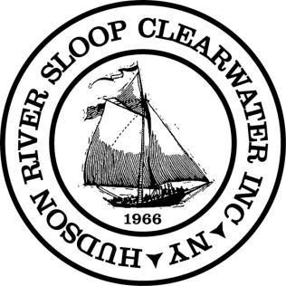

Hudson River Sloop Clearwater
www.clearwater.org

Inspiring, educating, and activating the next generation of environmental leaders.

Expectations of Clearwater Board Members

- Be or become a CW member (at the highest level appropriate) before election.
- Be passionate about the environment and Clearwater's mission. Tell Clearwater's story, sail on the sloop, and volunteer for the organization. Contribute time, expertise, knowledge and contacts in support of Clearwater and its mission. Buy tickets to fundraisers, attend the Revival and support it through Patron Fish. Sign up new Clearwater members.
- Be familiar with CW’s bylaws and policies and communicate them to membership.
- Seek out and represent the ideas of members. You are their representative.
- Be an ambassador for Clearwater, leveraging your personal and business social capital to actively build the donor, sponsor and fan base, as well as the membership base of the organization.
- All Board members must be committed to supporting the financial health of Clearwater, and all Board members must make a financial contribution. The Board’s total goal is to give or get an amount equal to 10% of the annual Clearwater budget. The individual goal for each Board Member is to give, get, or contribute professional services, comprising at least $1,200 per year. Each Board member will work with the Development Director to develop ideas and implement an annual plan to support Clearwater's fundraising needs. (See below.)
- Serve and work on at least one committee.
- Prepare for, attend and contribute in Board Meetings (in person preferred). Meetings generally are held monthly at the main office in Beacon and usually include Annual Gathering, New Board Member Orientation, one or more Board/Staff Retreats and an evening or weekend day. Agendas, reports and other materials are distributed and should be read in advance.
- Serve out elected term. Board members serve no more than 3 terms of 3 years each.
- Prospective Board members can be nominated by the Nominating Committee or by a petition signed by 5 Board members or 30 Clearwater members. The slate of candidates is then approved by the Board, after which CW members vote by mail-in or in person at Annual Gathering. Candidates are encouraged to introduce themselves at Annual Gathering just before final ballots are cast.
- The new Board typically meets the afternoon of Annual Gathering to elect the new Executive Committee of the Board and set meeting calendar for the upcoming year. The Executive Committee that consists of President, Vice President, Treasurer, Secretary and three (3) at large members (except for the Secretary and the Treasurer, it is very uncommon for new Board Members to serve on Executive Committee). For orientation, a meeting with staff will be held at the office a few weeks thereafter, to prepare for the annual November budget meeting.
- Develop a relationship with Clearwater staff and membership. Be a visible presence and an active supporter of Clearwater programming at the office in Beacon, on board the sloop and other Clearwater programs and events.
- Help out as requested by Clearwater board, staff and captains, and where possible, provide in kind services.
Hudson River Sloop Clearwater

History & Programs

In 1966, Pete Seeger launched the effort to “build a boat to save the river.” He believed a majestic replica of the sloops that sailed the Hudson in the 18th and 19th centuries would bring people down to the river where direct experience of its beauty, fragility and desperate plight would make them want to protect it and restore its health. Over more than three decades, Pete’s original conception has grown into a template for environmental education and grassroots advocacy replicated by organizations around the world, and the Hudson River Sloop Clearwater has become America’s environmental flagship.

Engage! Clearwater re-connects Hudson Valley residents with their cultural heritage and traditions by bringing them back to the river for the Great Hudson River Revival – the defining summer music festival of the Hudson Valley – as well as concerts and public appearances throughout the year. These events serve an important role in bringing information on environmental issues to the public and showing people how they can make a difference. Our unique approach to public outreach has made the Clearwater the symbol of the American tradition of moving citizens to action through music and shared culture.

Participate! To date, more than half a million people have experienced their first real look at an estuary’s ecosystem aboard the sloop. Clearwater takes children out on the water for a perspective on their world that they might not receive from any other source. Our long-view strategy is widely recognized for helping to create vocal communities that value clean water, clean air, open space preservation, toxic waste remediation, environmental and social justice and other sound environmental decision-making. Each season, Clearwater environmental education programs serve more than 12,000 students.

Our programs meet New York State curriculum guidelines, as well as the requirements of environmental studies programs throughout New England.

Activate! Today, Clearwater provides students, families and concerned citizens with education and tools that help them protect the river and the environment in their own communities. We offer a continuum of opportunities to learn about, defend, and restore the river, and we help citizens take action on issues of critical concern to the environment and to the health and safety of their families. Through five decades, Clearwater members have initiated or joined virtually every significant battle to protect the Hudson River, deploying our strength in marshalling grass roots community participation and educating grassroots environmental leaders.

The Clean Water Act, which celebrated its 40th anniversary in 2012, began to take shape in 1970 when Pete Seeger sailed the Clearwater to Washington and set up an impromptu concert in the House of Representatives office building. Pete was named one of 30 National Clean Water Heroes in honor of the 30th anniversary of the Clean Water Act.

Clearwater helped craft and pass the Hudson River Park Act on Manhattan’s riverfront. Our capacity for mobilizing citizens was instrumental in winning the battle for General Electric to remove its PCBs from the River – Clearwater collected 69 municipal resolutions and more than 11,000 petition signatures in this effort. Our ability to organize at the community level makes us a critical partner in the campaigns to ensure performance on the EPA’s Record of Decision regarding PCBs, decommission the Indian Point nuclear reactors, prevent construction of a St. Lawrence Cement plant in Hudson, and develop a sustainable energy policy for New York State. Clearwater was a partner in the effort to save the beautiful Palisades skyline in Fort Lee. Our group effort persuaded LG to redesign its headquarters to stay low and out of sight of the river and nearby parks and trails. We join with our sister organizations to limit the risk to the Hudson posed by river-crossing gas pipelines and underinsured juice tanker cars transporting volatile fuels by rail.

Clearwater’s Goals

The purpose of Clearwater is to defend and restore the Hudson River, one of the great and historic rivers of this nation. Clearwater does this by:

- investigating and collaborating on research into sources of contamination or ecosystem disruption of the Hudson, its tributaries and watershed

- informing the public of such dangers and to assist the public in taking measures to stop and or mitigate such contamination

- educating the public about the environmental and ecological importance of protecting and restoring the Hudson River, its tributaries and contiguous waters through programs on land, aboard the sloop, and in schools.

- fostering the teaching of the natural history and cultural heritage of the Hudson River Valley from the mountains to the sea;

- concerning itself with the well-being of people living in communities of various sizes in the watershed and especially along the river.

- mentoring those who may wish to protect and restore other great waterways; and to conduct other actions including, but not limited to, litigation that will enhance and improve the environment of the Hudson River Watershed.

About Raising Money
It is the intention of the Board that an individual’s personal ability to give should not be an obstacle to board membership. To that end the board has directed the Development Director to work with each board member to develop a fundraising plan for the year. Below are some examples of board efforts in the past:

Give:
Supporting Sloop, Holiday and Patron Fish Appeals.
Becoming a sustainer (monthly Credit Card gift).
Purchasing wood or supplies for the boat.
Donating a needed vehicle or equipment.
Planned Gifts of real estate, insurance policies, stock, personal property (tools, vehicles)

Get:
Hosting house parties.
Calling/meeting major, lapsed, potential donors.
Identifying and helping write grant proposals.
Identifying and helping securing corporate sponsorships.
Locating and securing donations of suitable wood for the sloop.
Helping charter the Sloop.
Helping sell in-school and shoreline programs.
Getting new or lapsed members to join Clearwater.

Professional Services:
Providing valuable professional services that directly offset the operating budget. Examples include renovation of CW office, legal services, milling wood, etc. These should be services which you have the skill to provide and which Clearwater is actively seeking.
Betsy Garthwaite, Board President
845-750-7880 (c)
captbetsy@verizon.net

Statement of Organizational Values
We cherish the Earth, the Hudson River and each other as we share our common voyage aboard this only home in space we know.
We cherish the presence and image of our vessel, Clearwater, as a dramatic symbol of this voyage, our mission and our values as we strive to serve as the “conscience of the river.”
We believe that people will be better caretakers of the Earth, this river and related waters, by learning from what has gone before and coming to understand, respect and love their environment.
We believe that helping the people of the Hudson Valley find a sense of place, which honors the River and its creatures, is essential to the conservation of these resources and to the overall well-being of us all.
We believe that effective outreach is best achieved through bold initiatives, actively involving others in a spirit of mutual respect, endeavoring to encompass the needs and aspirations of diverse communities and individuals.
We believe that celebration and music are vital parts of our voice.
We believe in honoring those people whose lives and efforts have contributed to our common heritage, with specific respect for Clearwater’s grassroots traditions and support.
We believe in holding ourselves to the highest standards in everything we do, encouraging the efforts of our colleagues and compatriots in an atmosphere of teamwork, ownership and empowerment.
We believe that external support for Clearwater must not compromise our mission, program content, or environmental and social stances.
Approved by Hudson River Sloop Clearwater, Inc Board of Directors
November 24, 1996

Representing Clearwater
Directors should keep in mind that they act as representatives of Clearwater. As with our members, our directors come in many different forms and packages, so they aren’t expect to look, act or speak in any one way, as long as they lend credibility to Clearwater.
Each director should provide a photograph and bio to the Secretary for inclusion on the Clearwater web site and other materials consistent with the following guidelines:
- The photo must be color, at least 200x230 pixels in resolution and less than 10 years old.
- The bio must at least implicitly answer three of the following questions.
  - Why would a donor trust you with $1M?
  - Why would a die-hard RPC member trust you to make decisions on their behalf?
  - Why would a die-hard environmentalist trust you to vet corporate sponsors?
  - Why would members of the Seeger family trust you with Pete’s legacy?
  - Why would staff members trust you with their livelihood?

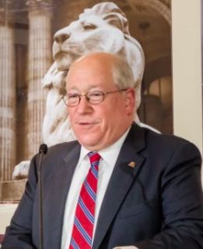
Example:
Seth Davis
Bethel, CT
Second term, expires October 2021
Seth Davis, a native of Croton-on-Hudson and a lifetime lover of the Hudson River, is one of the most prominent environmental attorneys in the country. Seth was Chair of the American Bar Association’s Section of Environment, Energy, and Resources, and has devoted his career to enabling cleanup and remediation of hazardous waste sites and guiding corporations to minimize their environmental impacts and provide safe workplaces for their employees. He is a regular speaker at the World Justice Forum in The Hague, leading discussions of access to justice on environmental issues throughout the world. He teaches as an adjunct professor in the highest rated environmental law program in the United States at Pace Law School, and has served his community as chair of its planning and zoning boards. He has served as an officer and director of several not-for-profit corporations in the arts and education field. Seth spent several happy summers at a camp where Pete Seeger’s music and social consciousness totally permeated the atmosphere.

Recommended Reading
The RIVERKEEPERS: Two Activists Fight to Reclaim Our Environment as a Basic Human Right Two Activists Fight to Reclaim Our Environment as a Basic Human Right
Cronin, John, Kennedy, Robert, Gore, Al

Pete Seeger: In His Own Words (Nine Lives Music Series)
Seeger, Pete, Rosenthal, Rob, Rosenthal, Sam

NOAA Chart 12343: Hudson River New York to Wappinger Creek 28.5 x 43.8
Paradise Cay Publications

Live Sustainably Now: A Low-Carbon Vision of the Good Life
Coplan, Karl

Drawdown
Edited by Paul Hawken

Robert's Rules of Order Newly Revised In Brief, 2nd edition (Roberts Rules of…
Henry M. III Robert

Trans Allyship Workbook: Building Skills to Support Trans People In Our Lives
Shlasko, Davey, Hofius, Kai

Going for Impact
Eugene H. Fram with Vicki Brown
Recommended by Janine Napierkowski, Board of Directors, 12/19/19: Quick, easy read that is an intro or refresher to board service basics.

Fundraising Habits of Supremely Successful Boards
Jerold Panas
Recommended by Janine Napierkowski, Board of Directors, 12/19/19: Another quick, easy read with solid ideas and real life examples.

Interpreting Maritime History at Museums and Historic Sites
Joel Stone
Recommended by Janine Napierkowski, Board of Directors, 12/19/19: Written from a Museum perspective, this book has interesting ideas and case studies for presenting content to the public.

Interpreting the Environment at Museums and Historic Sites
Debra A. Reid and David D. Vail
Recommended by Janine Napierkowski, Board of Directors, 12/19/19: Again, written from a Museum perspective, this book outlines ways to interpret environmental issues for the larger public audience.

Restorative Practices Handbook
Bob Costello, Joshua Wachtel and Ted Wachtel
Recommended by Janine Napierkowski, Board of Directors, 12/19/19:This book is written for school teachers and administrators, but I think it has some great lessons everyone can use when working with diverse groups of people.

Getting to YES
Roger Fisher and William Ury
Recommended by Janine Napierkowski, Board of Directors, 12/19/19: Great easy read that simplifies negotiation tactics.

The Island at the Center of the World
Russell Shoto
Recommended by Janine Napierkowski, Board of Directors, 12/19/19: Fascinating read about the development of early New York City.

The Hudson: a History
Tom Lewis
Recommended by Janine Napierkowski, Board of Directors, 12/19/19: I think this book offers a good basic history of the river.

Taking Care of Wooden Ships
Maynard Bray

The Sloops of the Hudson River
Paul Fontenoy

Heartbeats in the Muck
John Waldman

Power on the Hudson
Robert Lifset

Rybka, Walter. “Suggested Standards for Replica and Reproduction Vessels” APT Bulletin, Vol. 19, No. 1, Maritime Preservation (1987), 69.

The Hudson: a Natural and Unnatural History
Robert H. Boyle

The Hudson
Carl Carmer

Index

A
Ad Hoc, 12, 14, 16, 18
Advisory, 12, C-35
B
Board Accountability, 6, C-10
Board Manual, 8, 16, C-18
Board Meetings, 20, B-5, C-10, D-1
Board retreats, 8, 16, C-18
Board Training Committee, 16
E
Election Judges, 14
Executive Committee, 11, 12, 13, 22, B-3, B-5, B-8, C-7, C-8, C-11, C-12, C-13, C-15, C-16, C-19, C-24, C-25, C-33, C-35, D-2
Executive Director, 6, 8, 11, 13, 15, 16, B-8, C-1, C-3, C-4, C-5, C-7, C-8, C-10, C-12, C-13, C-14, C-15, C-18, C-19, C-23, C-26, C-33, C-35
F
festival, D-3
Festival, C-30
Finance Committee, 15, C-24, C-26, C-35
G
Gala Committee, 19
give or get, C-6, D-1, D-6
Governance Committee, 15
M
Meeting Minutes, 21
mentor, 8, 16, C-18
minutes, 8, 16, 21, 22, C-12, C-18, C-24, C-25, C-31
moral owners, 6, C-10, C-21
N
Nominating Committee, 7, 8, 12, 13, 16, B-3, B-4, B-6, C-14, C-15, C-16, C-17, C-18, C-19, C-20, C-24, C-26, D-2
O
Officers, 9, C-12, C-19
P
Planning Committee, 15, C-24, C-26
President, 9, 12, 13, 20, B-2, B-3, B-5, B-6, C-1, C-3, C-4, C-5, C-6, C-10, C-11, C-12, C-19, C-20, C-23, C-24, C-25, C-31, D-2, D-6
Program Committee, 15, C-24
Properties Committee, 15, 16, C-24, C-26
purpose, 4, 5, 13, 19, 20, B-1, B-4, B-6, B-7, C-1, C-5, C-6, C-14, C-15, C-16, C-23, C-25, C-30, C-33, C-35, D-5
R
Revival, 18, D-1, D-3
S
Secretary, 9, 13, 21, B-2, B-3, B-4, B-5, B-6, B-7, C-12, C-16, C-17, C-19, C-24, C-25, C-31, D-2, F-1
sloop, C-4, C-35, C-36, D-1, D-2, D-3, D-5, D-6
Sloop, B-1
SLOOP, 14, B-7
Sloop Club Review Committee, 14, B-7
Standing, 12, 13, 14, 15, 17
T
Treasurer, 10, 13, 15, B-2, B-3, C-12, C-19, C-26, D-2
V
Vice President, 9, 13, B-2, B-3, C-12, C-19, C-20, D-2
Vice-President, 9

See Policy V. Policies of the Not-For-Profit Corporation Hudson River Sloop Clearwater, Inc. Regarding the Orientation and Training of Board Members on p.32
See Certificate of Incorporation Hudson River Sloop Restoration, Inc. reproduced on p.11 of this manual.
See By-Laws of The Hudson River Sloop Clearwater, Inc. reproduced on p.22 of this manual.
See ARTICLE XII AMENDMENTS on p.27.
See Error! Reference source not found. reproduced on p.30 of this manual.
See ARTICLE XIV ADMINISTRATIVE DUTIES on p.28
See ARTICLE II PURPOSEof By-Laws of The Hudson River Sloop Clearwater, Inc. on p.7
See Policy X. Ends Policies of the Hudson River Sloop Clearwater on p.42
See I. Board Accountability on p.24
See Policy V. Policies of the Not-For-Profit Corporation Hudson River Sloop Clearwater, Inc. Regarding the Orientation and Training of Board Members on p.32
See Section 2 on p.B-2 of ARTICLE V DIRECTORS AND OFFICERS.
See Section 2 on p.B-2 of ARTICLE V DIRECTORS AND OFFICERS.
See Section 2 on p.B-2 of ARTICLE V DIRECTORS AND OFFICERS.
See Section 2 on p.B-2 of ARTICLE V DIRECTORS AND OFFICERS.
See Executive Committee on p.B-25 of Policy IX. Policies of the Not–for-Profit Corporation Hudson River Sloop Clearwater, Inc. Regarding the Organization and Functioning of its Board of Directors
See Section1 of ARTICLE VI DUTIES OF OFFICERS on p.B-2
See Paragraph D on p.B-15 of 1. Recruitment & Nomination of Directors in Policy IV. Policies of the Not-for-Profit Corporation Hudson River Sloop Clearwater, Inc. Regarding Recruitment and Nomination of Board of Director Candidates
See Section 2 of ARTICLE IX ELECTION OF DIRECTORS on p.B-5 of the Bylaws.
See Committees of the Board on p.B-24 of Policy IX. Policies of the Not–for-Profit Corporation Hudson River Sloop Clearwater, Inc. Regarding the Organization and Functioning of its Board of Directors.
Committees of the Board, p.C-26
Committees of the Board, p.C-26
See Executive Committee on p.B-26 of Policy IX. Policies of the Not–for-Profit Corporation Hudson River Sloop Clearwater, Inc. Regarding the Organization and Functioning of its Board of Directors

