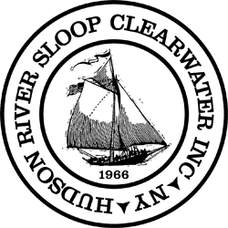

DRAFT Minutes of the Meeting of the Board of Directors
Hudson River Sloop Clearwater, Inc.

Virtual Meeting via Zoom

Wednesday, September 8, 2021 at 6:30pm

Board Members
Peter Capek Seth Davis
Jeff Domanski Mitzi Elkes Joan Gaylord
Neil Gordon, Treasurer Scott Greathead
Allen Gutkin
Samantha Hicks, Executive Committee At Large Gareth Hougham
Arthur Jones, Executive Committee At Large Aaron Mair

Janine Napierkowski, Vice-President
Henry Neale, Executive Committee At Large Jeremy Rainer
Gregory Simpson
Steve Stanne, President & Acting ED, Chair Donna Stein
Rosemary Thomas
Sarah Underhill, Secretary Greg Williams
Thomasina Winslow
(strike through indicates absence)

Staff Members Hal Cohen
Mannajo Greene Amali Knobloch Erin Macchiaroli

Meg Mayo
Nick Rogers

Members

Jeremy B
George Bossa
Victoria Christof
Roger D’Aquino
Allan Goldhammer
Joyce Hanson
Betty Harkins
Ben Kaminsky
Deb Kavanah
Noel Kropf
Rick Nestler
Laura Selleck
Alan Thomas
Roy Volpe
MJ Wilson
Pat [not otherwise identified]

The Meeting was called to order at 6:30 pm
Mission Song by Steve, “How Can I Keep From Singing”

With corrections submitted by directors, the minutes of the 6/9/21, 7/6/21, and 8/9/21 meetings were approved in separate voice votes.

A PROPOSAL that all committee and staff reports be attached to minutes was APPROVED, with fifteen ayes and four abstentions.

Acting Executive Director’s Report
Steve Stanne presented the following report.
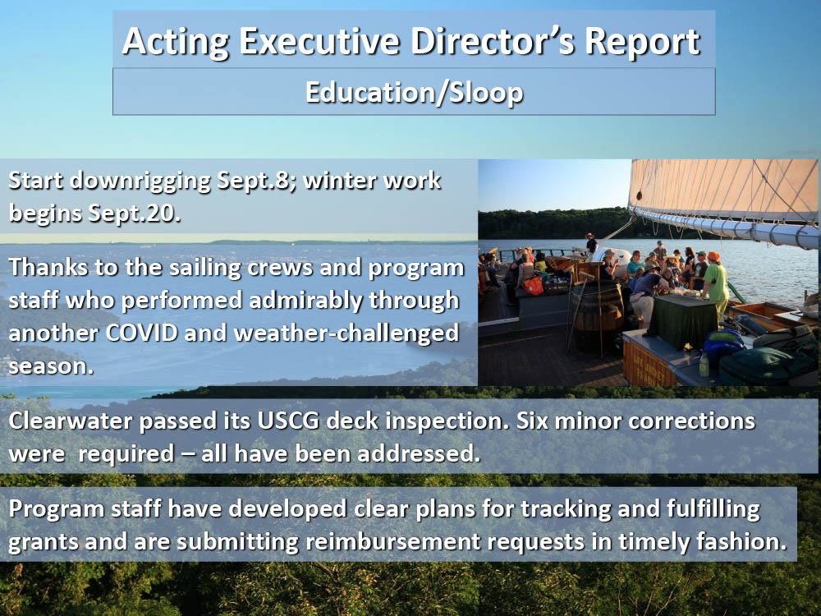
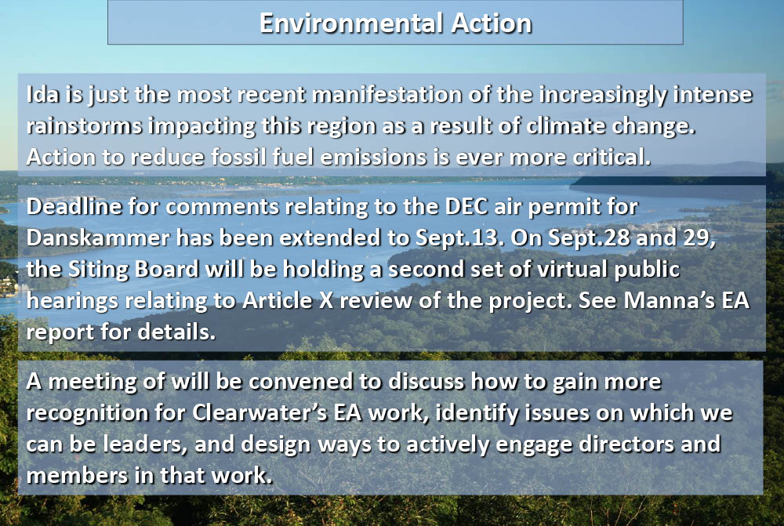
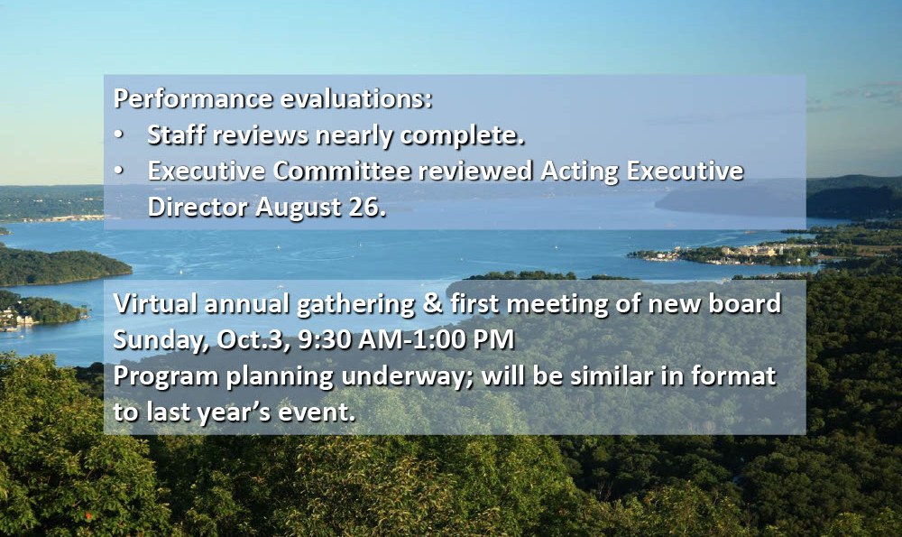

Treasurer's Report
Neil Gordon presented the following report.
I’m pleased to report on the status of our (i) cash flow and general financial condition, (ii) status of financial reporting, and (iii) importantly, my view on our ability to fund an event (i.e., “Festival”) at Croton Point.

Cash Flow and General Financial Condition
Cash flow challenges remain. After funding a significant loss from our last Festival, and the loss of nearly all of our operating revenues due to COVID, we’ve now survived two sailing seasons and a winter maintenance period, and are reasonably well positioned to survive this year’s winter maintenance season, as well.

The Century Fund balance is growing, reimbursements from prior grants are in process and applications for anticipated Sloop work are being readied. This combination should adequately fund 75% of the planned winter projects. After anticipated reimbursements, the Century Fund will have been restored so that future winters can be similarly funded, hopefully in perpetuity. In the spring, (hopefully) a revenue richer, post-COVID sailing season will generate much needed cash flow. As always, the generosity of Clearwater members and friends sustains us.

Financial Reporting Status
Limited cash flow, limited time, the complexity of grant accounting (including a lack of seamless integration between our accounting software and our donor software), and other factors, continue to delay our financial reporting, both external and internal. Established as priorities are needed government filings, and audited financial statements. All of those are under pressure of deadlines.

As frustrating as a lack of periodic financial statements might be, we are not, as an organization, “flying blind.” Our expenses consist of payroll for staff and crew, and necessary spending (e.g., insurance and debt serviceWe are, of necessity, managing to available cash flow, which we’ve done without incurring additional debt.

Festival at Croton Point
Lastly, but importantly:
Passion for Festival runs high. There have been and will continue to be robust discussions (including tomorrow evening) about where Festival fits in our mission, its history as a fundraising event, its value as an membership/outreach event, and more. Here though, is the dispassionate reality: There is not yet a proposal for a Croton event that fits within our available cash flow and ability to sustain a potential loss.
This is not a close callMoving forward with an event at Croton Point, as proposed, would commit funds we don’t have, and present risks we can’t afford. Please keep this reality in mind during this evening’s discussion.

Development Committee/Development Report
Meg Mayo presented the Development report. For theThe OPRHP reimbursement request was submitted August 19th. For the Century Fund, major donor outreach continues and public outreach will begin in the near future. A draft of the Century Fund cash flow and a snapshot of Century Fund budget vs. commitments was reviewed. Meg also covered Development Revenue for the past month, the Development Calendar for September through December, a Grants Pipeline update, and shoutouts to Board /members /Staff who have supported development efforts in the past month.

An important reminder regarding Amazon Smile: Designate Hudson River Sloopn Clearwater as your charity of choice before your holiday shopping season begins! (https://smile.amazon.com)

An
Rosemary Thomas presented the Development Committee report.
1. The following proposed Development Committee charge was put forward for a vote of the board:
RESOLVED: that the following Development Committee charge be included in Board Policy IX, Organization and Functioning of the Board:
In order to further the goals and objectives of the Corporation's Strategic Plan, as adopted from time to time, the Development Committee is charged to work with the Development Director and/or Executive Director to determine, plan, and fulfill fundraising goals for the Corporation. For example, the Development Committee may assist in designing fundraising strategies, establishing relationships with major donors and granting entities, or planning and executing fundraising events. The Development Committee may, in consultation with the Finance Committee, approve the annual and long-term fundraising goals.
The Resolution was PASSED UNANIMOUSLY.
2. Hike for the Hudson was deferred. We simply could not get all the pieces together in the time needed.
3. Gala 2022 planning has started!
4. Century Fund - please support!

With work on the sloop’s winter overhaul about to begin, Steve requested authorization to spend money from the Clearwater Century Fund for the project. Captain Nick Rogers expected work to be done through the second week of November to cost $119,810. The fund specifies that withdrawals are to be made with reasonable expectation of reimbursement. That reimbursement is to come from the OPRHP grant, in the amount of 75% of actual expenditures. This would allow a withdrawal of $89,858. Steve and Neil recommended a withdrawal of $95,000 to allow a cushion in the event that spending over this time is higher than expected. The following resolution was put forward for a vote of the board.
RESOLVED: that a withdrawal of up to $95,000 from the Clearwater Century Fund, is hereby approved, in such amounts as may be approved by the Executive Committee from time to time, with all such amounts subject to a reasonable expectation of reimbursement.
The Resolution was PASSED UNANIMOUSLY.

In expectation of hiring an auditor, Steve put forward a resolution requesting authorization from the board to do so.
RESOLVED: that the Board of Directors approves the hiring of an accounting firm to conduct the annual audit(s), and that the Executive Committee be authorized to approve the choice of a firm.
After discussion, Aaron Mair moved to call the question; his motion was seconded by Rosemary Thomas. The motion to call the question was passed with 17 votes yes, 2 votes no.
The Resolution then was PASSED with 16 votes yes, 1 vote no, and 1 abstention.

Nominating Committee:
Arthur Jones reported that a Meet the Candidates event will be held via Zoom on 9/13/21 at 6:30 pm. Questions for the candidates may be submitted in advance to the nominating committee.

Planning & Governance Committee:
In addition to approval of Development Committee charge, Rosemary put forward several other proposed changes to Policy IX, Organization and Functioning of the Board. These included changes to the names and texts of charges for several committees. These updates will help current and future Board members more clearly understand the role of each committee and perhaps more easily determine where they can contribute. She will resend these for approval at a future board meeting.

Properties Committee:
Henry Neale as Chair requests that a board member who has expertise in maintaining the Sloop join the committee. We have that expertise in the person of Captain Sam Hicks, but policies currently restrain her from serving on more than two standing committees. It was suggested that Planning and Governance examine the question of whether to keep that restriction.

Executive Director Search:
Janine Napierkowski reported that applications are coming in and times have been set aside for interviews.

Sloop Club Committee
Donna Stein reported that a monthly sloop club committee meeting has been difficult to schedule. She will stay in touch with the clubs on an individual basis. She encouraged Board members to join their local Sloop Club.

Revival Planning
At this point it’s not possible to plan a small 2022 festival in and around the city of Beacon given uncertainties regarding COVID and availability of dates for Pete and Toshi Seeger Riverfront Park.
An extensive discussion of the Croton festival proposal prepared by Ben Kaminsky followed, addressing the following resolution:
RESOLVED: that Clearwater shall commit to producing a Great Hudson River Revival at Croton Point Park in 2022 at the scale and cost proposed in the documents titled Fest Options 2022 and 2022 Festival Budget VS 2017 Budget, which were presented to all board members on 8/26/21 and again on 9/1/21, and shall be attached to the minutes of this meeting.
Points repeatedly made: Revival is an important and beloved part of Clearwaters’s identity; a Croton Revival 2022 as proposed is too financially risky; the board needs to commit more fully to collaborate with RPC to plan for a realistic and sustainable festival; such planning should go forward soon for 2023; Ben did a great deal of work in putting together proposal which will be valuable in planning; Clearwater has failed to set aside funds raised by Revival for Revival; given its financial difficulties, the organization couldn’t afford to do so; not holding an event at Croton in 2022 risks losing the preferred dates to other events.
The Resolution FAILED TO PASS, with 3 votes in favor, 13 opposed, and 1 abstention.

The Board went into Executive Session at 9:37 pm to discuss finances.

The meeting was adjourned at 10:27 pm

Respectfully Submitted,
Sarah Underhill, Secretary

Attachments
2022 Fest Options
2022 Festival Budget VS 2017 Budget

