Fall 2015- Navigator Piece

As the summer winds down and we prepare to welcome the fall season I would like to thank all of the volunteers who worked to make this year’s Great Hudson River Revival another wonderful weekend. The true spirit of Clearwater’s volunteers could be seen through the rain and shine, and I am sure next year’s festival will only be better! This fall we will be focusing on providing volunteers with online training videos and materials to teach residents about various environmental issues in the Hudson River Valley and ways to help solve them. We will also be gearing up for the third phase of our sloop restoration by welcoming people from all over to our winter open boat gatherings at our home port in Kingston, NY. Over music and a potluck meal, attendees will be able to follow the work on the sloop and hear the story that lead to the making of our historic tall ship.

*Maybe end it by asking people to join us for the open boats or to visit the volunteer page on our site to be kept up to date about events we will have and ways they can participate.

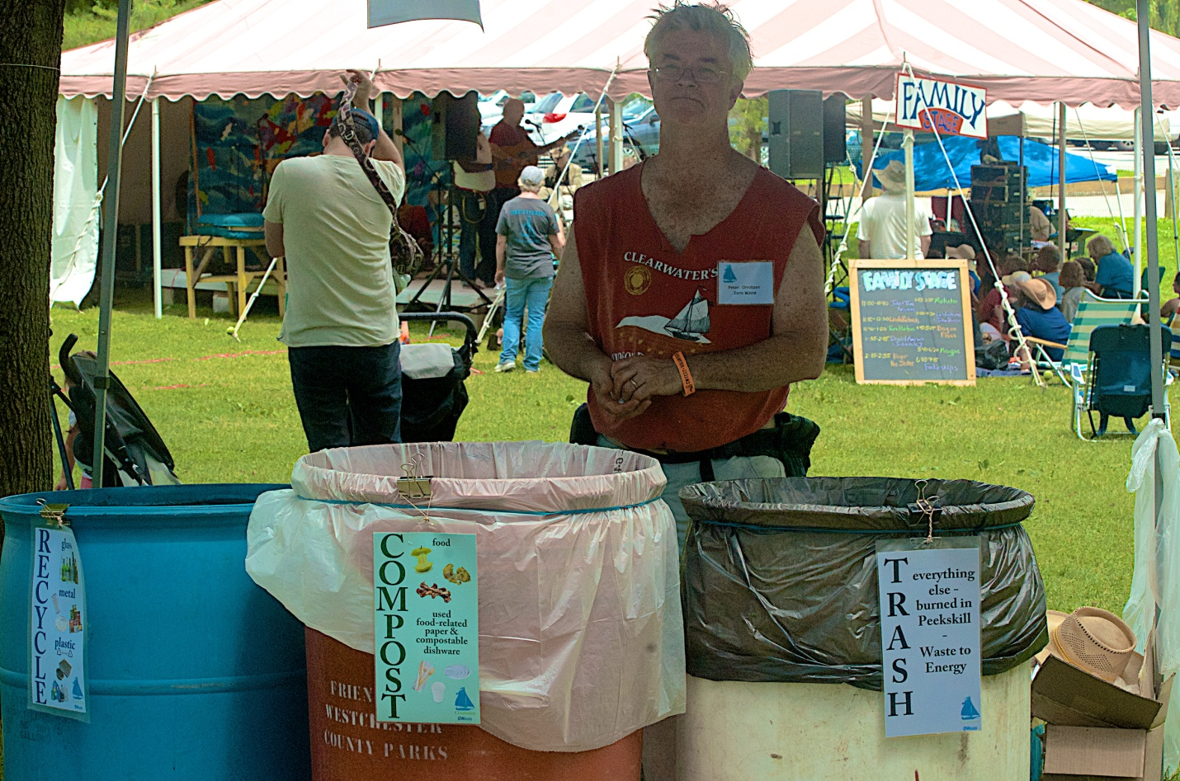
(Users- Everyone- Photos- 2015-08-26 2015 Festival Volunteers- “REVIVAL - 2015 - VOLUNTEERS 31”).

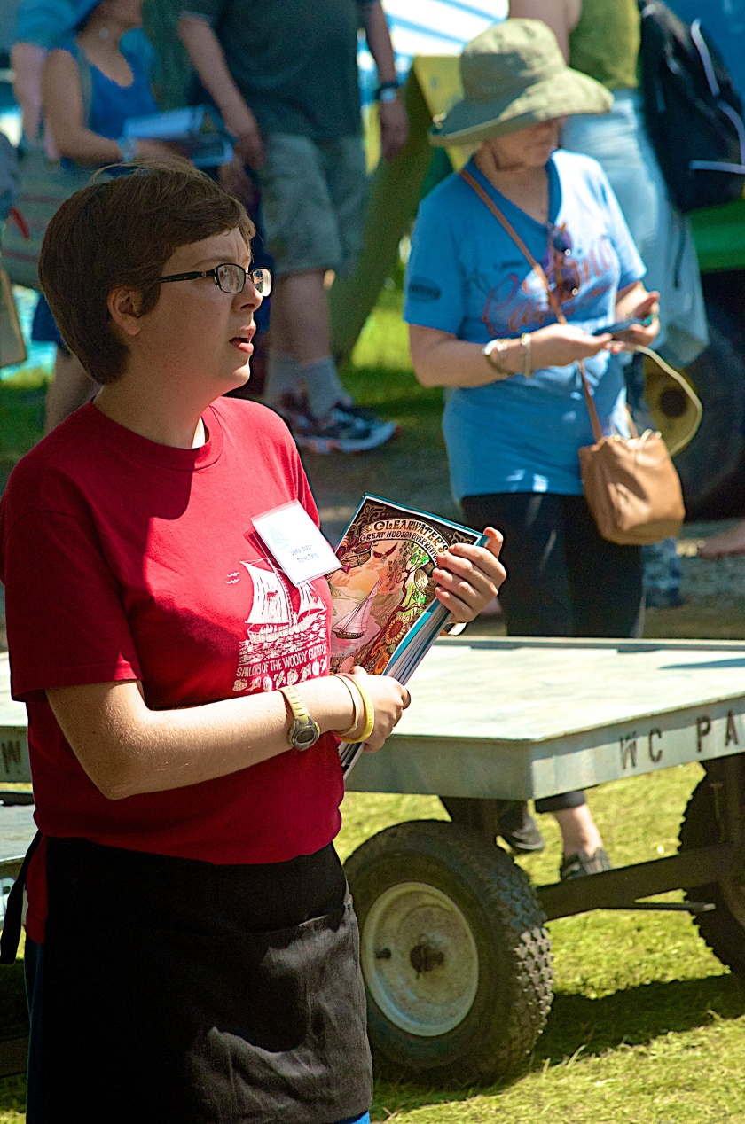
(Users- Everyone- Photos- 2015-08-26 2015 Festival Volunteers- “REVIVAL - 2015 - VOLUNTEERS 38”).

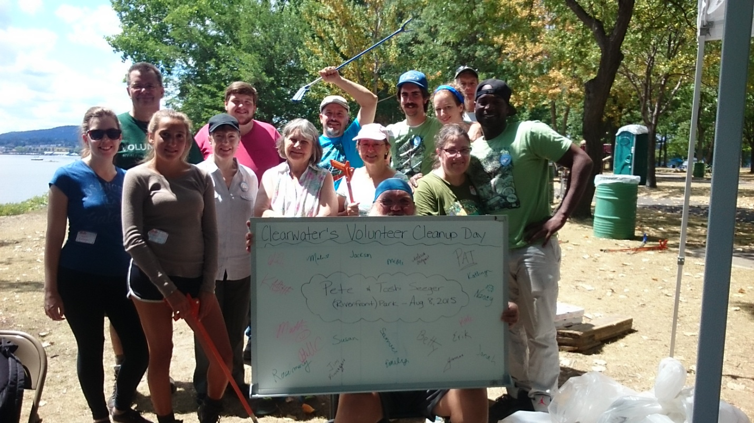
(Users- Everyone- Photos- 8.8.15 Pete & Toshi Park Cleanup- “Group Photo 7”).

